Back Remedy

These are some standard Bowen moves for lower back pain

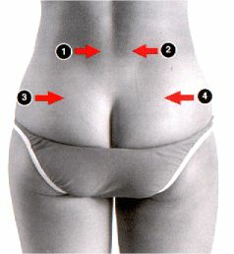

Lie down on a bed, face down. Try and get comfortable and relaxed.
Get your partner to place his thumb at the base of the red arrows.
The thumb is not allowed to move or slide on the skin.

The movement of the the thumb on the skin dictates how far the move will travel. Usually not too far.

Start at number 1 - it is important to do this in the order numbered on the diagram.

Now, with the thumb on the base of the arrow, get your partner to push in a little, but not too much that it gives you pain. Move the thumb in the direction of the arrow, keeping in mind the thumb is not to slide across the skin.

The thumb moves only as far as the skin movement will allow it.
You can do moves 1 and 2, no more than 3 times in the one session.

Next do moves 3 and 4 the same way. Notice how the arrows line up with the top of the crease in your buttocks. You use the top of the crease in your buttocks as the vertical guide as to where the thumb is positioned.

You can push in hard here, when doing this move, but you must avoid pain, do not push so hard that it causes pain.

