1. Using any tape available, tape together two (2) C or D size batteries with the plus and minus ends touching together:

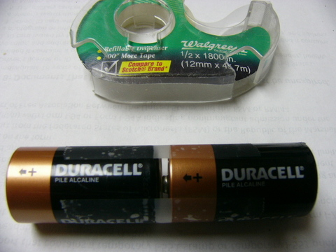
Notes:

2. Each battery has 1.5 volts for standard, and 1.2 volts for rechargeables. It does not matter which kind you use:

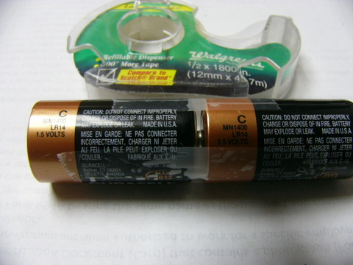

Notes:

3. Place two(2) rubber bands alongside the end and wrap around with a third rubber band. Stretch over piece of sponge. Cellulose sponges or natural, not plastic foam, they must hold water. Cloth can also be used:

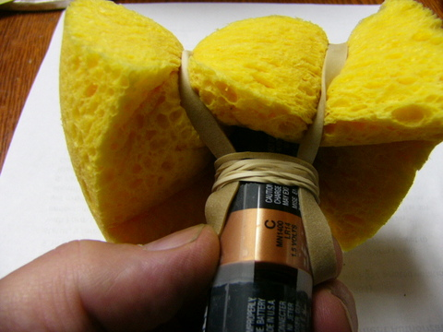

Notes:

4. Side view. If cloth is used, try about 5 or 6 thickness cotton cloth:

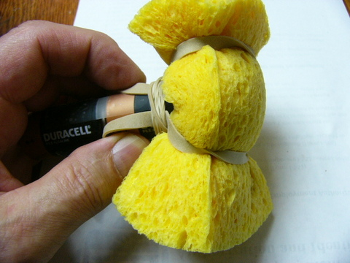

Notes:

5. This shows a completed rod. It's the same on both ends. One end will be battery (+) the other end (-):

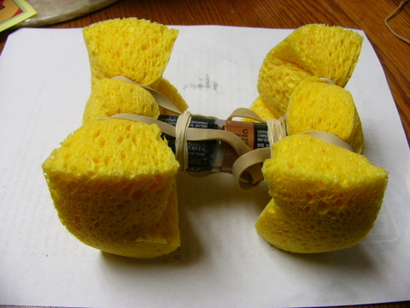

Notes:

6. Top view. Any means of attachment can be used like tape, string, or insulated wire:

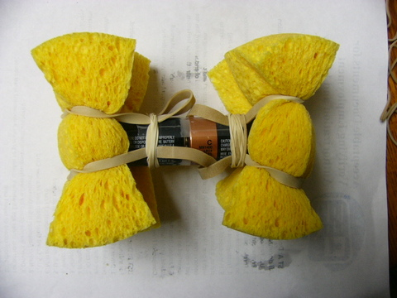

Notes:

7. Make 2 of them. Usually 1 is enough, but sometimes nicer and faster to use 2:

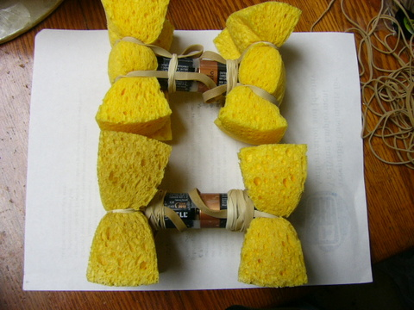

Notes:

8. Author shown applying one rod to oral/nasal cavity. This is for researching one side infections. Current goes through hand and face to make circuit:

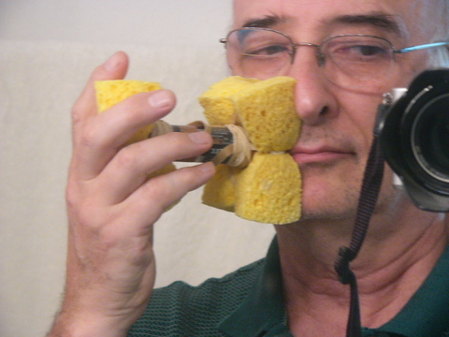

Notes:

9. Author shown with 2 rods for 6 volts application for teeth gums and sinus research. Current is doubled and goes through hands and across and through facial area:

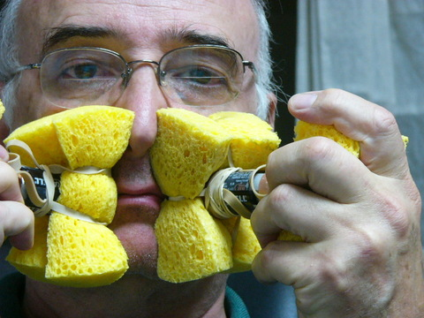

Notes:

