BULLOUS IMPETIGO http://www.hmc.psu.edu/healthinfo/i/impetigo.htm
19-year-old (otherwise healthy) female 2006 Above, on, and below the back of the left knee

Day 17-8/30 Wed Day 19-9/1 Fri Day 21-9/3 Sun Day 22-9/4 Mon
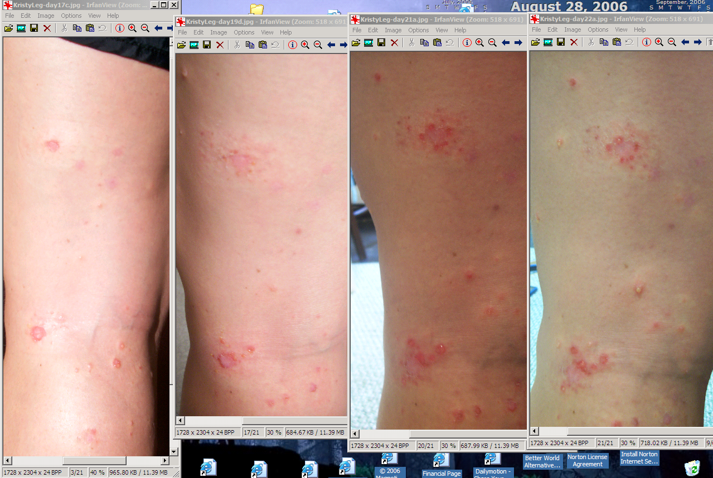
Day 17 – Almost all the sores are weeping clear fluid
Day 19 – There are more sores and it’s spreading. All new blisters are weeping.
Day 21 – Still more sores spreading. This night patient started using the Global Wellness RIFE machine, frequency channels 20, 49, 50 (for Staphylococci infection, and Streptococci infection). Also wore Don Croft style zapper, nights 21, 23-today
Day 22 – Can’t really tell any result from RIFE/Zapper - new blisters continue to form.

Day 22 9/4 Mon Day 23 morning 9/6 Day 23 evening 9/6
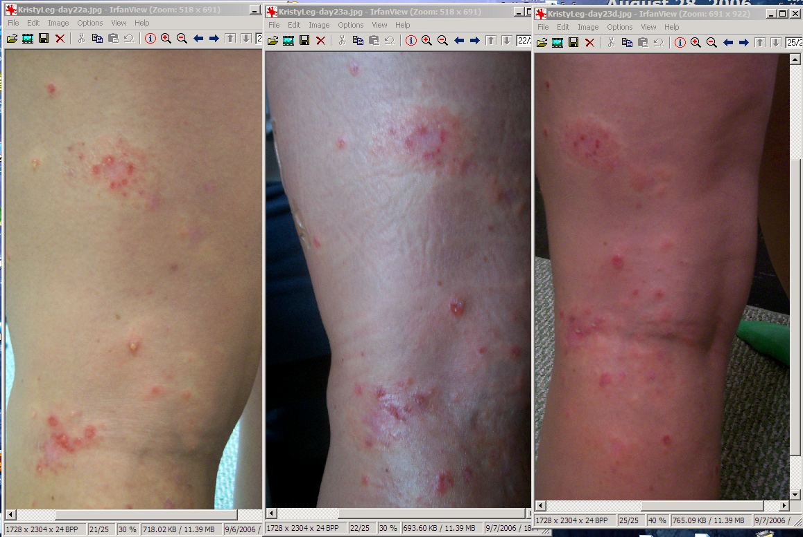
Day 23 -morning was the first day patient said it was “much better” and looked like it was finally starting to heal! ☺
Day 23 –evening patient was starting to get excited. I couldn’t tell; looked worse to me, but she said it FELT better, and felt like it was starting to dry up.

Day 24 9/7 11:04 PM Day 25 9/8 7:25 AM Day 28 9/11 7:25 PM
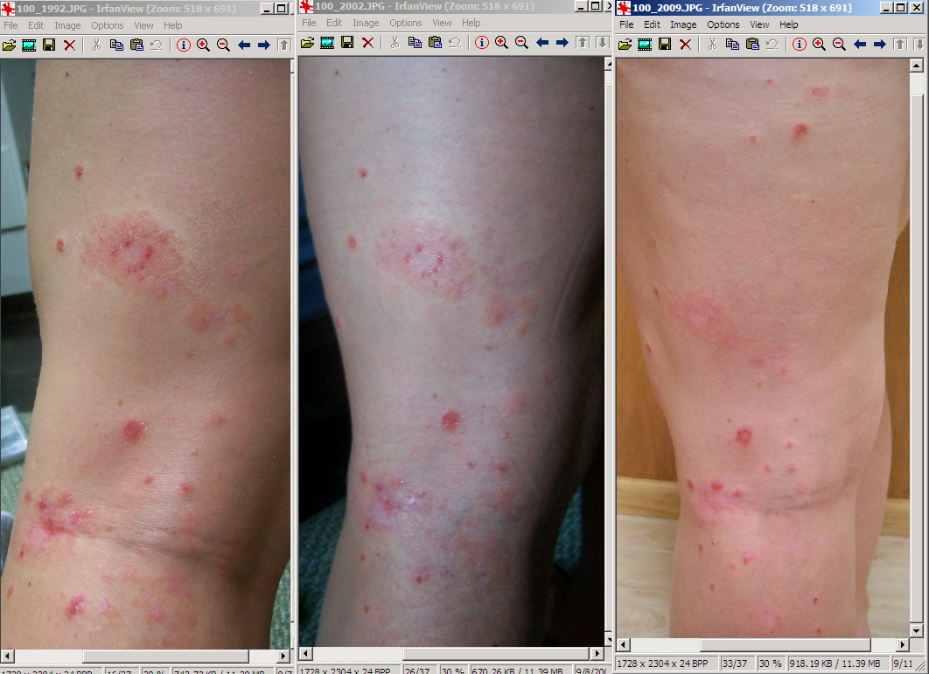
Day 26-27 patient did not take pictures because the camera was having problems; needs to be repaired.
Day 28 Significantly better! No new blisters; all sores drying up; scabs dropping off; ON THE ROAD TO RECOVERY!

