http://www.quantumbalancing.com/magnetic_blender.htm

The Amazing Magnetic Blender
Ron Cusson, Ph.D
Many months ago, I purchased the book "Occult Chemistry" and I have been studying it since then. My studies led me to design the magnetic blender shown below.
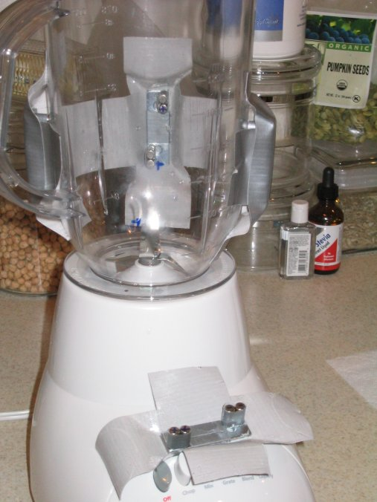
This is a simple modification to the Sumbeam 4141 blender ($14 at discount stores) to allow it to magnetize water so strongly that the ORMUS matter in the water becomes highly charged. This project requires 16 cylindrical magnets such as those from www.kjmagnetics.com, stock number D48, NdFe rare earth magnets arranged outside of the plastic blender container. Each magnet has poles on the flat ends and measures 1/4" dia. X 1/2" long. The magnets cost under $20. The magnetic assemblies consist of 4 magnets and 2 steel mending plates measuring 2" X 5/8" X 1/16" (available at most hardware stores) which are configured as illustrated below.
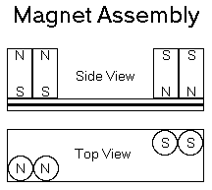
Also see the picture of the blender above with one of the magnetic assemblies removed from the blender and sitting on top of the blender speed buttons.
The size and orientation of the magnets is crucial to the effectiveness of the blender charger.
The polarities of the 4 magnets are written in blue at the ends of the magnets, 2 plus at one end and 2 minus at the other end. The end of the plate assembly that holds the magnets labeled + is called the positive end of the plate assembly.
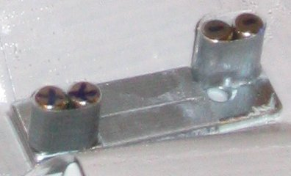
The 4 assemblies are mounted vertically, magnet side in, and equidistant around the outside of the blender bowl (In the original prototype above they are held in place with duct tape). They must be mounted away from the spinning blender blades - above the 8 and below the 24 ounce marks on the blender bowl. They are oriented so that a positive end on top alternates with a negative end on top as they are attached around the blender bowl. This maximizes the number and speed of flux reversals as the water vortexes around the blender cup and, in turn, this will induce very large alternating eddy currents in the water as it goes around, therefore aligning the ANU in synchronicity with the alternating current.
The starting water can be distilled water with Celtic salt added at a rate of about 300 parts per million (300 mg of salt per liter of water). It can also be any electrically conducting mineral water. It will be the ORMUS in the Celtic salt and in the water that will be charged during the blending. However, the starting fluid can also be concord grape juice and indeed many other combinations of electrically conducting liquids. Typically, 1 liter of liquid is blended at high speed for 3 minutes to produced the effects of the ORMUS charging.
Here are some of the results observed so far.
I put 300 mg of Celtic salt in 1 liter of distilled water (does not affect the taste much), a few drops of Tamahi Calcium (which is probably some kind of "ORMUS gold") and ran this in the blender at high speed for 3 minutes. The first time I took this, I had a strong rush after only 10 minutes and ALL my joint pains vanished right there and then and never returned. That was weeks ago!
I drink this water full time now and the best description of the experience is that it is "as if" my little finger tip is in contact with my little toe and the two of them are communicating at dizzying speed, if that makes any sense at all! I sleep less and wake up more rested. My outlook is more positive than before starting the magnetized water regimen.
I have been watering some plants with magnetized water over the last few weeks of frost here in the South. The magnetically watered plants have been blooming in spite of the frost while the regular plants are loosing leaves. It's like night and day!
In another experiment, I took 1 liter of cheap wine, rather bitter and rough on the palate, added 300 mg of Celtic salt to it and ran it through this magnetic blender for 3 minutes! What came out was a totally different liquid. It was thick, smooth, almost "oily" on the palate, sweet and heady, like the most expensive European dessert wines that achieve the "slick" mouth feel with a ton of sugar. This modified wine seems to put alcohol in my bloodstream way faster than the starting wine, too!
I have also done this with grape juice, with similar results, but without the negative side effects of the alcohol rush!
I do not have a "consensus" explanation for the transmutation of the liquids in this way. But I do know the following: there is a law called Lentz's law that give the amount of "electrical current" flowing in a liquid that is crossing lots of magnetic lines of force at high speed. I have arranged the magnets to maximize this current (v.g. the presence of the Celtic salt!)
In Occult Chemistry, they show a diagram whereby the ANU are "aligned" when a current flows in matter. The Celtic salt makes the water conductive and large AC currents (sometimes called eddy currents) are flowing in the liquid when the blender is running. The harmonic content of the AC current seems to be between 30 hertz and 5 kilohertz, from my calculations! Because the current is AC, the ANU are undergoing "collective/coherent" vibrations in the above frequency range. Larger diameter magnets or a wider magnet spacing will change this to a lower frequency which seems to be less effective.
One surmise would be that this coherent vibration of the ANU may be creating a collective high intensity field resonance that could dislodge the ANU from being localized inside a single water molecule and allow the ANU to become free to "roam" the entire bulk of the liquid, thus causing quantum coherence over the entire container. The number of ANU that are "liberated" in this way seem to grow with the length of time that the liquid is being processed. Because I got such a strong rush after 3 minutes of processing, I have not yet tried to ingest water that would have been processed, say for 1 hour, with a lot more Celtic salt in it (to increase the conductivity and therefore the current).
In a related enterprise, I have developed a magnetic homogenizer around a high power commercial blender and many strong magnets around it (Warning, strong magnets can cause lots of damage and pain if not handled properly!), using the ideas mentioned above for the Sunbeam kitchen blender. This magnetic homogenizer has been put in service to manufacture a new mineral supplement called Green Ionic Minerals (GIM, for short, pronounced JIM). The ingredient list of this new mineral supplement is given in the picture of the label below.
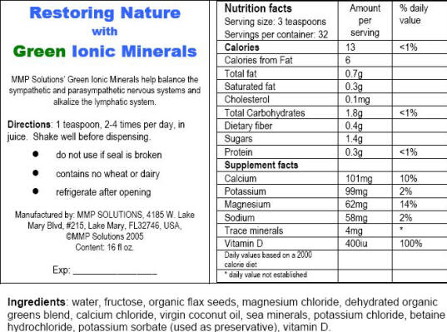
This new supplement is available by sending an e-mail to martin@life-enthusiast.com and he will explain how it is possible, for a limited time, to participate in an introductory test program for this new supplement. What is remarkable is that this supplement has a much sweeter taste, after magnetic homogenization, that it would have otherwise. The starting taste is the bitter metallic taste of the minerals.
Currently experiments are being conducted to observe the effects of adding the GIM in the starting water in the magnetic blender. One expectation is that the magnetic blending will accelerate the effects of the GIM, in that the homeopathic imprint of the GIM can be dispersed throughout the water being magnetically blended.
More generally, one also might try adding herbal mixes to the water and Celtic salt before doing the magnetic blending. One expectation is that the herbal mixture will be much stronger afterwards because of ORMUS related homeopathic imprinting of the magnetized water.
Of course, there is a long list of smoothies that can be made to taste a whole lot sweeter with little added sugar, by blending the smoothie in the magnetic blender. Similarly, hot tomato cream soup acquires a silky sweet taste when blended magnetically and many other blended dishes take on an entirely new character when blended magnetically. Enjoy!
With friendship,
Ron Cusson, Ph.D.
http://www.restoringnature.com

