The
Blood Purifier
Handbook

There is convincing evidence that the
Blood Purifier may provide
an inexpensive non-drug cure for AIDS!
Plus cancer, herpes, lupus, hepatitis-C,
and kill almost any microbe, virus, fungus, yeast,
or parasite infecting one's blood.
Cleaning the blood can help give you the
industrial strength immune system you need
in this day of bioterrorism threats,
and may even help take off excess weight.

. . . . Wayne Green

Several decades ago there is a well documented record of an old man being struck by lightning (and surviving). He proceeded to grow a third set of teeth, a bushy new head of dark hair, his inoperable cancers disappeared, he no longer needed his glasses and cane, and was completely healthy. Perhaps the mystery of his astounding rejuvenation has now been accidentally discovered and can be put to use by anyone. Is it possible that two doctors at the prestigious Albert Einstein College of Medicine in New York discovered a cure for AIDS, patented it, and then kept it a secret?

Patsy?

A patsy is a person who is easily duped or victimized. If you'll read some of the medical industry expose books I review in my Secret Guide to Wisdom you'll understand what Grade A patsies all of us have been when it comes to our trust in doctors.

Is it really possible that two scientists at a leading research hospital have made one of the most important medical discoveries of the 20th century-a simple, inexpensive cure for AIDS, malaria, hepatitis-C, etc. -and kept it a secret?

The Blood Purifier

Here's a fairly simple device which can pass a small electric current through your blood, zapping out any virus, microbe, parasite, fungus, or yeast infection living there---infections which are helping to depress your immune system so it can't do its job of protecting you from germs and infection, get rid of defective cells before they can form cancers, and repair damages you do to your body.

In these days when we're concerned about surviving bioterrorism, you want to have an industrial strength immune system. Truly healthy people don't get sick, no matter what is going around. However, according to the Department of Health, fewer than 1.5% of Americans are truly healthy.

If you've been living with arthritis, diabetes, obesity or some other chronic disease rather than change your lifestyle to raw food -and stopping poisons such as milk, sugar, coffee, pasta, pizza, Big Macs and so on, it's time to rethink that decision and make a major change. My Secret Guide to Health goes into the gory details of the many ways we knock our immune systems for a loop and make ourselves sick. You don't get any illness unless you've compromised your immune system, so when something vicious does come along like anthrax, a new and deadly flu, or something, you'll be one of the first to go.

Bye.

Disclaimer

First, please understand that I am a journalist (and publisher), not an M.D. I read, research, and ask a whole lot of questions- then I report what I've discovered. As a journalist I tend to want things to make good sense as well as be supported by credible research before I accept them. Also, just to make sure, before I publish something in book form I usually publish it in a 73magazine essay, where it is read by thousands of readers. They let me know when they think I'm off base. Boy, do they!

As a journalist I was instantly curious when Jim Morrissett, a long time friend (50 years) and fellow ham (K20LK) mentioned that Bob Beck, a mutual friend of ours, had discovered a way to cure AIDS with some kind of electrical gadget. I called Bob, who confirmed his discovery and faxed me the background information and a schematic for the fairly simple device.

Bob had noticed a little piece in Science News (page 207, March 30, 1991) about two doctors at the prestigious Albert Einstein College of Medicine at Yeshiva University in New York City who accidentally discovered that when they passed a tiny electrical current through HIV-positive blood that it prevented the virus from attaching to the white cells and replicating, thus killing it. Wow, a cure for AIDS! That shouldn't have been a little squib in Science News, it should have been front page news in the New York Times!

But, having read Racketeering In Medicine by Dr. James Carter (see a review on page 6 of my Secret Guide to Wisdom), which exposed a long history of covering up inexpensive cures for expensive illnesses by the AMA, NIH and the FDA, I was not surprised. And if that book isn't enough to shake your belief in doctors, read The Medical Mafia by Dr. Guylaine Lanctot (reviewed on page 15 of my Wisdom Guide).

Or you can check out Dirty Medicine by Martin Walker (p.20 Wisdom Guide). Until you've read this book I doubt you'll believe the lengths to which the company making AZT has gone to squelch any competition.

John Robbins' book, Reclaiming Our Health (p.38 Wisdom Guide) documents the New York Times being in bed with the AMA and the cigarette companies. With all this heavyweight pushing of the AMA agenda, I won't blame you if you don't want to believe what I've discovered.

Why would doctors, hospitals, the AMA (with the full support of the FDA), go to extreme lengths to hide inexpensive cures for serious illnesses such as AIDS, cancer and heart disease? You know the answer as well as I do. It's the money. Just follow the money. Doctors make zilch when you are healthy. And, when you get sick, they only make money until you get better. While many doctors may be well meaning, the medical industry is driven, like every other industry, to make as much profit as possible. Doctors, hospitals, pharmaceutical and insurance companies only make money when you get sick, so they have an enormous vested interest in you're getting sick and staying sick for as long as possible. Ditto nursing homes.

Further, human nature is such that most people won't spend a dime on health until they lose it, then they'll spend whatever they have or can borrow to stop the painful symptoms which their lifestyle has produced.

A number of the books I've reviewed in my Secret Guide to Wisdom tell about inexpensive cures that the medical industry has buried. Am I exaggerating? You may remember the Australian doctor (Marshall) who discovered that stomach ulcers are caused by the Helicobacter Pylori microbe, which can easily be eliminated with antibiotics. It wasn't until an article in The New Yorker blew the whistle that the AMA reluctantly admitted that the doctor was right. Ulcers had been a huge money-maker for doctors -and still are for about 60% of them, who haven't yet gotten the word, or have ignored it if they have.

That said, if you have AIDS, you know first hand the terror this "death sentence" strikes in those who suddenly find themselves HIV-positive. The medical industry, backed solidly by the AMA, the FDA, NIH, WHO etc., claims there is no cure, and they are busy spending billions of dollars (most of it your money via the IRS, via Congress, lobbyists and special interest pressures) looking for a drug with which to treat the AIDS symptoms -a drug that can be patented and will bring in billions of dollars in sales from the desperate.

What they are not looking for (and successfully have suppressed), I'm afraid, is their worst nightmare: an inexpensive, simple cure. Nor, despite the efforts of Peter Duesberg, who wrote Inventing the AIDS Virus, have they been even remotely interested in the connection between lifestyles and AIDS. My Secret Guide to Health explains how we're making ourselves sick, and how we can quickly reverse the process.

Our medical industry only makes money when you get sick, so no matter how much they talk about health and call themselves a "health care" industry, or how much they wave the Hippocratic Oath at us, we have every reason to believe it is a Hypocritic Oath (oath, in the sense of a curse).

Can there really be a simple, inexpensive, fairly fast cure for AIDS that is being kept a closely guarded secret by our medical elite? And could it also cure things like hepatitis, Eppstein-Barr, herpes, syphilis, gonorrhea, lupus, malaria, Lyme Disease, and maybe even help cure cancer? And all this with a little electronic gadget that any experienced electronic hobbyist can build in a weekend?

If you've listened to Bob Beck talking at a Global Sciences Congress, or on the Coast To Coast AM radio talk show when Hilly Rose was the host, you've heard it all in detail. He's explained how difficult it was for him to uncover the story and track down the patents on this new approach to curing AIDS which are being quietly held by some very prestigious hospitals-and yet are not being used.

Our doctors are taught, and thus know, very little about health. They are only taught how to repair us after we break down, not how to prevent us from breaking down. They are taught to tackle our illness symptoms mainly with drugs and surgery. With the backing of the FDA, the pharmaceutical and insurance industries, the AMA and their thousands of lobbyists, the National Institute of Health, the World Health Organization, and an unquestioning media (kept quiet with billions of advertising dollars), they're doing their very best to prevent us from pursuing any alternatives -they're even trying to stop us from buying vitamins and mineral supplements to improve the abysmal nutrition our supermarket food and huge farm conglomerates supply.

There are many examples of pioneers discovering inexpensive cures for illnesses, only to be put in prison by the FDA and have their laboratories and inventions destroyed. If you think I am exaggerating, you need to take a good look at several of the books on my Secret Guide to Wisdom (which you should do anyway. Let's help fight ignorance). For goodness sakes please read about Royal Rife and his super microscope which allowed him to confirm Bechamp's theory of disease (instead of Pasteur's). When he discovered a simple way to cure cancer as a result, they put him in prison and destroyed his microscopes. Please read Barry Lynes, A Cancer Cure That Worked (page 6 of my Wisdom Guide).

Well, you say, you don't believe something like that could ever happen. Our government wouldn't cover up a cancer cure, not when the National Cancer Institute is spending billions of your money (via the IRS and Congress) on research. Oh, sure, do you really believe they're going to let some hick doctor close down billions of dollars of scientist welfare by admitting that cancer research is no longer needed? If you think that you aren't much of a student of big business, and you sure don't understand how Congress works. Money drives the almost $2 trillion medical industry, just as it is driving Congress to back the industry as a result of the medical industry's thousands of lobbyists in Washington and every state capital. The AMA isn't wasting the $17.1 million a year their lobbyists invest in Congress.

If you were the president of the National Cancer Society, drawing down $12 million or so a year, with over 10,000 employees and a campus of buildings, all supposedly devoted to finding a cure for cancer, what would you do if some guy came in with an inexpensive cancer cure? Would you discredit or kill him? Well, several doctors have, and I'll bet you or your doctor have never heard of them. Are you familiar with the work of Dr. Day? Dr. Comby? Dr. Bieler? Dr. Koch, Dr. Budwig?

It seems to me as if every industry I've gotten involved with has been crooked to the core. When I got into the music business I had no idea that it was so thoroughly corrupt. But when I researched the situation, I found that six music mega-companies (five are foreign owned) had 96% of all record sales. And several thousand small independent record companies had only 4% of all sales.

My, oh my! Maybe you missed the article in Forbes exposing the industry and showing that 98% of all performers on those six major record company labels never make a dollar of royalties. Creative bookkeeping, like that used by the movie industry, makes millionaires of a tiny handful of performers and billions for the record companies. Almost all performers either go on endless grueling concert tours or go hungry.

Maybe you remember the Jefferson Airplane? And then Jefferson Starship? Well, Marty Balin and his group, recorded a CD in my state-of-the-art digital recording studio on my Green With Envy label and made far more royalties than they ever did with the major labels. Fact! If you'd like to get the CD or cassette of his Better Generation, just send me $10 and I'll mail you one, while they last. It made the charts and you'll love it.

I got so fed up with the way the major labels dominated the music market that I circulated several million sampler CDs of independently produced music and helped get their sales up to 16% of the market. I still have some left, so if you'd like to hear some fabulous music I'll send you a list. All I want is enough to cover my manufacturing and storage costs. Each CD has about 15 tracks of a one kind of music, each the top rated track from an indie CD release. Music can be an industrial strength stress reducer.

I've been in the publishing business for 50 years now, so I know it pretty well. The magazine distribution industry is controlled by a small group of national distributors. You deal with them or you don't get your magazines on the newsstands. In my experience most of Them are skimming about 50% of all revenues right off the top (probably unreported and thus tax free). So when I get a distributor report showing 40% of my magazines have been sold for a particular month, I know it was really more like 80%.

Yes, these things have been exposed, but it all quickly blows over. Dannen wrote Hit Men, a book which described exactly how the major labels, with help from the Mafia, prevent independent record companies from getting their music played on the radio. Sure, it costs the majors about $100 million a year under the table to bribe radio station music directors, but that's peanuts to the over $20 billion in record sales that result. Half of one percent.

Well, our beloved and trusted medical industry is just as corrupt. Read Chris Bird's The Persecution and Trial of Gaston Naessens. He, like Rife, invented a super microscope and was able to rediscover the real cause of germs, as had Bechamp and Rife. He, like Rife, came up with an effective cancer cure as a result. Then he, too, was arrested and his microscopes confiscated. No, I'm not making this up! It's happened and it's still happening today.

And there are plenty of more exposés, if you flick off your TV, get off the couch, and do some reading. Hey, it's your body you're messing up and then they're charging you whatever the traffic will bear to treat the resulting symptoms. They know that once you feel pain and terror, your pocketbook is wide open for them to take everything they can. $2,000 a day for a hospital bed? Sure! Why not? Hey, I was on the board of directors of the Monadnock Community Hospital, so I know the inside of this crooked business.

Quacks and Charlatans By The Gross

One of the unfortunate results of medical industry corruption is the reaction of millions of people looking for alternatives. As a result, in the medical alternative industry the corruption seems no better! There are crooks and the naive at every turn. I have a large file of ads for health letters, plus endless convincingly-written sales pitches for nostrums. If I sucked into all of this garbage I'd be spending $50 to $100 a day for pills, powders, capsules, and such. Lordy, I hate to think what all this garbage is doing to the gullible!

The worst part is that some of these probably really do help, but I have no way to find out which are real and which are hogwash. The medical establishment, being corrupt, isn't about to run tests and tell me that taking tree resin pills or Tahitian Noni will cure almost anything ailing me. So, if they've ever run any tests on these nostrums, they sure don't seem to have published the results. If there were any, I'm sure the nostrum purveyors would cite them in their ads with big headlines.

And that brings me to what may well be a very inexpensive cure for AIDS, as well as a way which can supercharge your immune system, which can then, in turn, help your body ward off and even get rid of cancer and a host of other illnesses. Your immune system is your first line of defense against invading microbes and body generated chronic illnesses. I'll go into other ways you can beef up your immune system later on.

My Secret Guide to Health explains how you can get over just about any illness and never have to worry about cancer, Alzheimer's and so on. You do this by eating the food your body was designed to handle, by avoiding the almost endless number of poisons which are plaguing us these days, getting plenty of sunshine and exercise, and reducing your stress. Classical music is a fabulous stress reducer, and if you don't know what music to get, yes, Professor Green has a guide for that, too. But, if you have AIDS, cancer, or some other life-threatening illness you want immediate action.

The AIDS Cure

I explained how Jim Morrissett got me in touch with Bob Beck, who faxed me the story, asking me to keep his address and phone number confidential. Fear of the FDA. Having read about the FDA’s heavy handedness, which is much like the BATF group that whacked Waco, and having myself experienced similar treatment by the IRS, I have honored his request.

Now, if you think I'm exaggerating about the FDA, please drop a note to Dr. Jonathan Wright at Box 84909, Phoenix AZ 85071 and ask for a copy of his letter explaining what happened to his Tacoma clinic. We may have the best country in the world, but it sure has some very serious problems, and most of them are caused by Congress and government bureaus, which have been busy taking away as many of the freedoms enumerated in the Constitution as they can get away with.

Anyway, the package Beck faxed me had a copy of an article about the Albert Einstein College of Medicine in New York City discovering that when they passed 50 millionths of an ampere of electric current through blood it prevented any virus in the blood from replicating, thus killing it. They claimed this approach eliminated the HIV virus, and thus was a cure for AIDS.

Scientists are still in the early stages of finding out how living things work. There are chemical, microelectrical, and biomagnetic communication systems. You'll find some of the books reviewing what researchers have been finding in my Secret Guide to Wisdom and in my editorial essays in 73magazine, which I've edited and published since 1960.

Also reviewed in my Guide is The Secret Life of Your Cells (p.5), which shows that in addition to the three communications systems above, there is a fourth more subtle system that scientists haven't even begun to explore. By what mechanism are cells from your body, kept alive in a laboratory, able to be in instantaneous communication with all of your body's cells, no matter where you are in the world?

This cell communication helps to explain the many cases of organ transplant recipients feeling the feelings of the donor, and even being able to come up with the donor's name! This also puts blood transfusions into quite a different perspective.

In light of what I've read, it made good sense that a small electrical current could prevent the HIV virus, as well as other viruses, bacteria, parasites and fungi in the blood from replicating and from being able to attach to the white blood cells, as reported by Drs. Kaali and Lyman.

Beek's ingenious innovation was a simple way to process the blood while still in the body, rather than having to drain it out, pass the microcurrent through it, and then put it back in again, thus stretching the process out over months of expensive hospital visits. Well, that made good sense and would be a much safer, faster and an infinitely less expensive approach. Beck suggested doing this via electrodes taped to the inside of the ankles, each over a major artery, which you can feel there. Since the blood is the path of least electrical resistance through the body, whatever voltage is applied would cause the current to go through the blood circulating in the leg arteries. And that's all of the blood circulating in the body.

Beck said it required about 25-50 volts to generate the needed 50 micro-ampere current. That's a very, very tiny current. But then our whole bodies run and communicate on just such micro-currents. If you'd like to know more about our human electrical systems you should read Dr. Robert Becker's Cross Currents (p.8 in Wisdom). Another must read is Becker's The Body Electric. The subtitle is "Electromagnetism and the Foundation of Life." It's 365p, only $11, and worth a lot more. I checked with an article I'd published about the body's electrical resistance and Beck's voltage calculated out as correct to cause the needed micro-current to pass through the blood.

At any rate, Beck's approach, backed by the Albert Einstein College of Medicine report, looked like it ought to work. It could turn out that this inexpensive non-invasive approach could be the answer to the whole AIDS threat! And I couldn't see any harm that could come from it as long as the current wasn't passing through the heart. Which is why Beck selected the ankles for his original research.

Beck's circuit was very simple. Essentially, it applied the current from four little 9V transistor radio batteries to the ankle arteries, switching it from positive to negative several times a second to prevent any polarization. He used an inexpensive integrated timing circuit to flip a tiny relay back and forth, and added a potentiometer (a variable resistor) in the circuit to allow the voltage (and thus the current) to be varied. The idea was to turn up the voltage until the current could be felt as a gentle thumping, but not high enough to be uncomfortable.

Beck said that there had been hundreds of cases where the unit had been used with success, and he said that there were 547 patients with AIDS being tested with his blood purifier system. On the strength of the concept's reasonableness, plus Beck's assurances, I made copies of his circuit and the instructions available to anyone who wanted them. I dropped a letter to the head of the National Institute of Health, asking if they had any interest in testing this approach. This resulted in a local FDA official coming to my office, demanding to confiscate any literature I might be sending out. Fortunately I was photocopying the information one at a time as requests came in, so I had nothing to turn over to the fed storm trooper. Life in the "land of the free and the home of the brave" sure can be interesting. Particularly for the brave.

Between a mention in my 73magazine and an interview on the Laura Lee radio talk show, I got several hundred requests for the information. In it I asked to be let know what the results of using the blood purifier circuit were, good or bad. More talk radio interviews brought more information requests, but no reports of either success or failure.

I did have a call from a street musician in Nice thanking me for the information booklet and saying that it had saved his son's life. His son had had AIDS and the purifier had cured him. I've been getting more and more letters about cancer cures, which I hadn't really expected. Just recently I had a letter from a 75 year old woman who said her doctor was so amazed during her last visit that he took a second set of x-rays, just to make sure. Her cancer was totally gone! But then, as I often point out, gratitude is the least felt of all human emotions, so I don't expect to hear from most people who've been using the blood purifier.

I got a nice letter from Carl Maggio, who wrote, "I feel like a different person, with all my aches and pains gone. I've lost 10 pounds, the last 10 pounds that I couldn't get off no matter what I ate or did exercise wise. I look younger than I have in years and feel better than I ever have. My digestive system is no longer giving me problems and I now weigh what I did in high school."

Carl's relatives and friends have been buying units, with an uncle reporting that his emphysema, which had made it difficult to get around was gone and he's now able to run up and down stairs.

Manufactured Units Are Available

Though the Beck circuit can be put together by an experienced electronic hobbyist with parts from any electronics parts house (such as Mouser Electronics 800-992-9943, which had the needed parts in their catalog and I have listed later in this book), most people are so freaked out by a schematic diagram that they can't even try to build anything electronic. They go to a Radio Shack, where they find that in most cases no one there knows a volt from an ampere, much less how to read an electronic schematic. Well, I've been reading 'em most of my life, so even complex circuits are like reading English for me. I can look at a computer schematic and understand what's in it and why. For this skill I thank the US Navy, not my college. In 1942 the Navy put me through a 9-month course that was spectacularly first rate. Who would ever expect our government to do anything right? It was a wartime anomaly, I'm sure.

Two readers have recently sent me versions of purifier circuits they've built. They updated the Beck circuit, eliminating the need of the noisy, battery-killing relay. The units are for sale, as long as the manufacturer can avoid being put in prison, tortured, and executed by the FDA. The manufacturer doesn't make any claims for curing anything, though I'm not sure that the distinction will faze the FDA. I remember that when they put Wilhelm Reich in prison they burned his books, destroyed his orgone generators and his laboratory. Then he managed to mysteriously die there. Yep, right here in America, not Guatemala! I presume you've read about the CIA-supported Guatemalan government death squads.

Orgone must be pretty powerful stuff for it to get the FDA that upset. Well, many people I knew personally at the time had built orgone accumulators and were swearing that they were helping cure all sorts of illnesses. Naturally the medical industry couldn't have anything like that going on.

I remember when the FDA broke into the Washington DC Scientology headquarters and ransacked the place, confiscating their E-meters, which were used to help with their auditing.

Of course, with the placebo effect able to cure anywhere from 50-80% of the people of almost anything, it's difficult to know when it's the belief instead of the nostrum that's doing the work. But the medical industry seems to have zero interest in finding out. I'm disappointed that there hasn't been any effort I've heard about by them to harness the placebo effect and use it. Well, if they could figure how to charge drug prices for placebos, that would spur research. On the other hand, I'll bet they are already selling us placebos at drug prices and with drug names. Plus the bonus of drug side effects.

When you read my Secret Guide to Health you'll find that I've discovered how you can use the placebo effect to not only improve your health, but to lose weight without dieting or the need for will power, which seems in amazingly short supply these days. This is one hell of a breakthrough and I'm proud of it.

Now, back to the blood purifier. If you are electronically challenged and would rather pay someone else to make a unit, I've located a source. Since it is illegal to sell medical electronic equipment which hasn't been FDA approved, the blood purifier can't be sold commercially.

But by an incredible coincidence (what are the odds!) there is a gadget available which uses the exact same circuit, but which is designed to speed the growth of plants by giving them an electronic nudge. This Plant Growth Stimulator generates exactly the same voltage and frequency as a blood purifier, and is available for a modest $150, plus $5 s/h in the US from Butterfly Products, Box 1729, Hiffsboro NH 03244, or call 603-588-2105. MasterCard or Visa are fine. This stimulator is similar to the unit described in this booklet, except that it uses only one 9V battery instead of three or four, and has a voltage multiplier circuit built in to make up the difference. This makes the unit lighter to carry around in your pocket, but it does use up batteries faster. I recommend getting a little $7 Radio Shack 9V (#2731552) battery eliminator unit to save on battery cost if you're going to use it a lot. Which you should.

No, there is no connection whatever between the blood purifier and the Hulda Clark Zapper, which, to the best of my knowledge is 100% a placebo stimulator. If you really sincerely believe it's doing something, it probably is. Otherwise it isn't.

I haven't yet found a reliable source for magnetic pulse units, which Beck recommends for knocking the HIV virus out of the lymph glands, where it hides, often for years, but I'm working on it. I haven't given this much priority since the pulse unit is so ridiculously simple to make (as described later in this booklet). I haven't pushed very hard to find a supplier.

Common Sense

Since not many of us are afflicted with AIDS, the main potential use for the blood purifier will probably be for helping to rebuild immune systems. The people I've talked with who have reported some remarkable illness cures (such as cancer, emphysema, lupus, Lyme Disease, herpes, and hepatitis-A-B-C) feel that it is probably the strengthened immune systems that are doing most of the work.

One chap wrote that whenever he feels a cold or the flu coming on he uses the blood purifier for a few hours and the symptoms quickly disappear.

But why not provide your body with the nutrients it needs to maintain a strong immune system instead of having to rebuild it every now and then. We know enough about the poisons which are making us sick to avoid them, and we know enough about nutrition to provide our bodies with what they really need. Not that you're going to find much of it in your local supermarket or restaurant.

But rather than go into details on that here, I suggest you invest in my Secret Guide to Health, which explains how you can change your living habits so that you won't need any emergency immune system repairs.

My Secret Guide to Wisdom is a review of the "books you're crazy if you don't read," and many of them substantiate what I teach in my health guide.

By changing your eating habits, stopping your ingestion of poisons, and exercising you can add 30-60 years of healthy life, plus not have to ever worry about a heart attack, stroke, arthritis, or being put into a nursing home. Or have you seen the TV exposés of how awful many nursing homes are? No? Then visit one. Please read my instructions and make the needed changes in your lifestyle.

Toxins

Since everyone's chemical system works a little differently, we're all sensitive to a different set of allergens. The scratch test, which I went through when I was around seven, when I suddenly developed hay fever and asthma, not long after being given a series of vaccination shots for childhood illnesses, is not very sensitive. A much much better way to find the things you're allergic to is the pulse test. Read the $5 pocket book by the same name by Dr. Albert Coca. Of course it's reviewed in my Wisdom guide (page 18).

Just by exposing your body to an allergen and measuring your pulse rate you can find out how sensitive you are. And that holds for pollens, dust, foods and drugs.

Dr. Coca found that by avoiding allergens, his patients were able to cure arthritis, multiple sclerosis, diabetes, ulcers, hemorrhoids, epilepsy, hives, overweight, and a wide range of other illnesses. Anything you do to lower the ability of your immune system to function is liable to have both long and short range effects, from chronic illnesses like cancer to colds and flu. You'll also want to read Dr. Doris Rapp's The Impossible Child (page 16 of my Wisdom Guide) to understand how allergies can radically change kid's personalities.

Nostrums Galore For You To Explore

I've been building a list of the alternative "cures" for illnesses.
Here's are some of the nostrums I've gotten very convincing literature on: Apple cider vinegar - essiac - kombacha. - chlorella vitamins A, C, and E -Gero Vita - saw palmetto - garlic - ginger oxygen - hydrogen peroxide -silver colloids - raw milk - Tai Chi sunlight & UV - UV treatment of blood -chelation - Swedish flower pollen extract - ginko biloba - five Tibetan rites -distilled water enchinacea - chromium picolinate - tree resins - magnets -orgone black walnut hulls & cloves - cayenne - GH3 - black cherry juice zinc - co-enzyme Q10 - barleygreen - crystal energy - cayenne pepper vanadium - copper - wormwood - shark cartilage - bilberry - Lcarnitine -ginseng - pyridoxine - pygeum - arbutin - magnesium flaxseed oil - blue-green algae - toddies - Tahitian Noni - colostrum, etc.

If you have anything more than hearsay evidence that any of these are worth while, please let me know. I do tend to put more stock in the nostrums endorsed by Dr. William Douglass of Second Opinion (800-728-2288) since the things he has been writing about have been supported by some very convincing books by other authors. Many of their books are reviewed in my Wisdom guide. He's against most of the poisons I've read about. Like the mercury in dental amalgam, chlorine and fluorides in our water, pesticides in our food, hormones and antibiotics in our milk and meat, and Electric Magnetic Fields (EMFs). He also has a most interesting book on AIDS, accusing the WHO of originating it and infecting Africans with it via TB inoculations as a means for world population growth control.

By the way, the world's leading researcher in the biomagnetic field, Dr. Ross Adey, is a good ham radio friend of mine, so I've been getting copies of his published scientific papers and they're scary. The power companies are spending whatever it takes to buy scientists to lie for them. Reminds me of the scientists paid by the tobacco people to not be convinced that cigarettes were harmful. And they've even gotten to Dole, who is now one of the few people in the world who isn't sure that nicotine is addictive. When money talks politicians sure listen!

How about root canals? You'd better read Dr. Meinig's book (p. 12, Wisdom Guide). I'm sure glad I no longer have any. What do you know about immunization shots? After reading about 'em I'm convinced that they triggered some lifelong health problems for me- like allergies, sinus and ear trouble. You'd better read the book on immunization by Walene James (p.7). I doubt you'll ever have another shot if you do, nor let your kids get shots. Maybe I should start a new religious cult you can join to help prevent your kids from being poisoned. My health guide explains how you can get around the system on this.

The book by Peter Duesberg, Inventing The AIDS Virus, is an absolute must if you want to know more about AIDS. If you still have any respect for our medical industry, this will probably help cure you of that brainwashing. Try to remember that hospitals kill over 300,000 through negligence and errors every year, according to a Ralph Nader research report. Plus another 80,000 die of illnesses contracted while in hospitals. Stay out of hospitals-they can kill you!

AIDS and Cancer

Several of the books reviewed in my Wisdom guide claim to cure AIDS and cancer. Yes, I've read the Hulda Clark books, but her stuff doesn't make scientific sense to me. One book I highly recommend is Dr. Comby's Maximize Immunity (p.8). It makes tremendous sense. I like his premise and his solution. You can confirm Comby by reading the Arlin-Dini-Wolfe book, Nature's First Law (p.20).

If you apply what they've discovered you aren't going to get AIDS or cancer. And if you have either you'll get rid of them. The downside is that the Comby approach takes time and you're in a hurry, so you want to know more about the blood purifier. I won't duplicate the information in my Secret Guide to Health, which you really should read. Using a blood purifier to zap the crud out of your blood is a sure immune system enhancer.

Sure, But What About The FDA?

The pharmaceutical companies have to spend about $350 million to get each new drug or procedure okayed by the thousands of bureaucrats at the FDA. And the process can take ten years, meanwhile supporting that huge FDA staff at public (your) expense. They're dealing with government employees, none of whom want to take any chances on lousing up their retirement pensions by okaying anything that could ever come back to haunt them. Like thalidomide. I sometimes joke that with the exception of the few who are good personal friends, government employees tend to be people who have been unable to get jobs as teachers.

So, even if Beck's blood purifier works like gangbusters, there is no philanthropist with $350 million to get the ten year acceptance process started. This expensive, time-consuming procedure assures doctors that there will be no inexpensive cures for expensive illnesses. Indeed, I've mentioned to some AIDS workers that there's a new approach to dealing with AIDS that they should at least check out. Check it out? They were furious. "AIDS is incurable," they shouted. They didn't want to hear anything about potential cures. But even if a company eventually did get the purifier okayed, they could never get their investment back. The purifier circuit is just too easy and cheap to make. Hundreds of Taiwan and Chinese entrepreneurs would have units on the market in a week for $50. Then $25. And finally, $9.99, batteries not included.

If you are able to find any book on the sickness industry that has a good word to say about the FDA, please let me know. They've okayed a bunch of drugs that are killing people. Others just keep us sick. Few seem of much real value. Almost none are even aimed at curing anything- they're mainly aimed at alleviating uncomfortable symptoms. And if you think I'm exaggerating, please bone up on the field via the books I've recommended.

But before the FDA it was probably even worse, with a proliferation of unproven electrical gadgets and snake-oils promising to cure everything from spic-itch to cancer. The down side is that in addition to protecting the public from crooks, they have helped build today's humongous fraudulent medical industry which is tapping Americans for almost $2 trillion a year!

Our medical system is about three times more expensive per capita than any other in the world. Yet we're l7th in health, l6th in longevity, and trailing 19th in infant survival. That's almost as bad as our public school industry, which is another giant fraud.

The FDA rules prohibit the manufacture, sale, lease, or even accepting a fee for the use of any assembled electronic device that claims or even implies any kind of cure for anything. The exception to this is any licensed practitioner who makes or modifies his own device for use in his own practice. Also exempted are people who make devices for research purposes, but do not commercially distribute them.

There is no law against anyone buying a kit of parts and assembling them, or publishing information on how to do this. It is then legal to perform research with the resulting apparatus at one's own risk and analyze the results. It's also legal to give an assembled kit to someone else free of charge.

The bottom line is that the data I'm providing is for informational purposes only. No medical claims are made or implied. As I said up front, I am not a medical doctor, I'm a journalist. I'm not claiming anything, I'm just reporting on what I've discovered in my research. When I find information I think may be of interest and value to people on any subject, I try to get it out. From there, you're on your own. If you have any curiosity at all about things you may not know about you'll enjoy the reprints of my essays from 73.

My Reading Recommendations

By the way, I've usually read at least a dozen books on a subject before finding one I'm comfortable recommending. I talk with people in the field and get more book recommendations from them. I've been talking or corresponding with a bunch of authors such as Bob Becker, Brian O'Leary, Pat Flanagan, Cleve Backster, Fred Jueneman, Christopher Bird, Harry Stine, and John Thomas.

So make a list of your chronic illnesses and then see what you can do about getting rid of them. One good start that is universally recommended by virtually every investigator is to stop eating white flour products and sugar. Every healthy civilization that we've introduced these two foods to has immediately started having our chronic illnesses and teeth problems. So, are you going to be out there skiing with me down West Buttermilk in Aspen when I'm 120, or will you be another acid-rain etched headstone in a seldom visited cemetery? I visited my family plot recently and found that my grave site is on a hill overlooking a McDonald's. Figures.

I've done fairly well. I eat meat sparingly. I've never smoked. Oh, I tried it when I was a kid and said to hell with peer pressure. I don't drink alcohol. Don't like it. Including beer. So I avoided the fraternity beer busts in college. I drank for a short time while I was in the Navy during WWII, just to fit in with my fellow crew members on liberty. When I got out of the Navy I stopped.

I've had no problem changing from al dente veggies to raw. At 80 years, my main miseries seem to be left over from childhood inoculations. There seems to be no way to ever get all that poison out of your blood once it's been injected. I brisk walk a couple of miles every day and I'll bet I can ski you into the snow. I love to scuba dive, and that takes a lot of energy. A tank of air lasts almost an hour and I'm usually swimming hard the whole time.

The Beck Purifier.

Word got around about how much the audience enjoyed my talk on the status of cold fusion at the Tesla Society Conference in Colorado Springs. Well, I never seem to be able to talk about just one thing, so I covered a bunch of different subjects. The result was a call from Dean Stonier, asking me to give a talk at his Global Sciences Congress in Tampa. Even though I was up to here editing and publishing 73 and Cold Fusion, plus trying to keep up with the blizzard of mail from an Art Bell radio interview, I enjoy giving talks. Plus it didn't hurt when I saw that Bob Beck was going to be on the program. That clinched it.

It also helped a whole lot when a sample purifier unit arrived from Beck a few days before the conference for me to try out. At Tampa I talked with Bob, carefully going over the sheaf of lab reports he'd brought, all showing one HIV cure after another.

Bob had originally recommended running the unit 5-20 minutes a day, depending on the severity of the infection. But experience had shown that an hour or two a day did a better, faster job. The body can only dispose of so much toxic waste at a time, so people with heavy infections will need shorter treatments over a longer period. Bob says it's important to drink an 8-ounce glass of distilled water 15 minutes before a treatment, and another after. Plus at least eight more glasses of water a day to help flush out the waste products.

For that matter, the books on water (see page 17 of Wisdom) claim that we are forever dehydrating ourselves. They say that we need to drink a lot more water to help flush out toxins. I'm drinking around 10 glasses of pure water every day. Beck is high on adding colloidal silver to distilled drinking water. No one writing about water recommends that you drink tap water, with its chlorine and fluorides, and who knows what crud from your and the city's pipes. You only want stuff in your water that you put there on purpose. Be sure to read the two water books in my wisdom guide.

If you, like most people, have been dehydrating your body (and your cells) for years, better make that 12 to 15 glasses of pure water a day for the next year or so. Dr. Day, when she was at death's door with breast cancer, drank 20 glasses of water a day.

Does the blood purifier circuit present any possible dangers for cardiac patients? It doesn't seem like there should be any when used as intended, but I'd suggest doctors testing this system proceed with caution. Beck's instructions now suggest placing the electrodes over the two arteries on one wrist (see page 39). This is much more convenient than putting them on the ankles, and the path for the electricity doesn't run through the heart this way, either.

What can you use for the ankle or wrist electrodes? The best are the high-carbon conductive rubber stick-on pads used for electrocardiograms. They're cheap ... around 12¢ each, and can be used with the same person several times. The pads can be cut in half lengthwise and pressed lengthwise along the ankle or wrist arteries, where you feel your pulse the strongest.

You can make your own electrodes by using about an inch and a half of bare heavy wire (#10 or so) with a small piece of flannel wrapped around it and held in place with thread. You dip the flannel into salted water containing some bleach for sterilization. A piece of 1-inch wide by 9-inches long elastic with a Velcro fastener to hold it in place wrapped around your wrist works fine. Just tuck the electrodes under the elastic over the arteries. I use a second elastic strap to hold the wires in place so I can carry the unit around in my jacket pocket and keep working. This is the type of electrodes that come with the manufactured units.

If you don't use the second wire-restraining elastic, one of the wires tends to break off at the electrode. If you don't have a soldering gun to fix this you'll need to buy or make another electrode cable. They're $10 from Butterfly Products.

I turn up the voltage until I feel a light thumping. I turn it as high as is tolerable, but not to where it is uncomfortable. With time you will be able to use more current. The flannel will dry out after a half hour or so and needs re-soaking to make good electrical contact.

Beck says you may feel sleepy, faint, or headachy after a treatment. This seems to be the normal detoxification and endorphin release result. If the detoxification becomes a problem he suggests you shift to every other day. He recommends you rest and relax for at least 45 minutes before driving.

Beck says the treatment should continue for about four weeks to make sure that the viruses (etc.) are dead. The idea is to stop the growth of both mature and juvenile HIV (and any other evil) cells. Oh yes, no alcohol for at least 24 hours before a treatment. Not even a beer. It's about time to stop putting alcohol and other poisons into your body anyway. Sure, like many other poisons, it feels good and is addictive.

Next, Those Pesky Lymph Glands

Since the HIV virus tends to hide in the lymph glands, often for years, once it's been eliminated from the blood stream you'll want to blast it out of the lymph glands into the blood so it can be finished off with the purifier. Beck came up with a simple system for doing this. He wound 150 turns of #14 enamel wire (no, the wire size is not critical) on a VHS tape spool to make a coil with which to magnetically zap the virus out of the lymphs. You'll need some plastic or cardboard disks glued to the spool to keep the wire in place. To energize the coil he bought a cheap used photo flash gun and wired the coil in series with the flash tube. Thus, when the gun is fired it not only flashes the tube, but also shoots a sudden high current pulse through the coil. You hold the coil up next to a lymph gland and out squiggles the HIV virus into the blood. If you want to know where the lymph glands are, buy a copy of Gray's Anatomy. It's usually on sale at the surplus book dealers. Or be cheap and go to your local library. See the diagrams on pages 624 and 633. If you can't find it, check Hamilton Booksellers, Falls Village CT 06031-5000. Catalog #386936, $16 with shipping charges. That's where I got my copy.

There was an item in Business Week for April 5, 1993, page 83, discussing this lymph AIDS storage problem. There were also two studies reported in the March 25, 1993 issue of Nature on this subject. To test your coil you can put a razor blade or paper clip on it and see if it jumps at least 3 inches when you fire the flash gun. Of course, if winding the coil and hooking it up is too difficult, you can always go to a holistic expo and buy a similar gadget for about $7,000. They're waiting anxiously for you.

Once the HIV is out of the blood stream it's time to use the lymph blaster. A headachy feeling within an hour after the lymph clearing process calls for reducing the number of pulses. Unless you are HIV positive, I wouldn't worry about all this. There hasn't been enough demand for a commercially-made pulse units to encourage any manufacturers to design and then tool up to make them in quantities.

The AIDS Controversy

Is AIDS a virus? Is it even connected with HIV? If you're involved personally with it you should read all of the arguments, including a book on AIDS by Dr. Douglass. He says, as I've mentioned, that it is a man-designed virus cooked up by the World Health Organization and spread on purpose in Africa via the WHO TB immunization shots. And there has also been an attack on homosexuals in America, claims Douglass. Whatever is going on, the blood purifier may be an answer. We have no choice but to check out the various alternatives to what the medical industry is offering. For starters we know their approaches just plain don't work. We know that the chemotherapy success rate is around 5% for cancer, and with terrible side effects. And we know they're not likely to even try to verify or disprove any inexpensive alternatives. We know that AZT is a horrible disaster. Just read the Walker book (it's in my guide) about the dirty AZT story.

Yes, It Really Works!

Bob apologized for not keeping in better touch with me, saying he'd been busy working with Investigational Review Board (IRB) studies at cooperating clinics.
The circuit diagram he included with his handout at Tampa was almost identical to the one he sent me two years before. The only differences had to do with putting a momentary-on switch in series with the LEDs so they wouldn't run down the battery, and reducing the batteries to three instead of four. This reduced the voltage from 36V to 27V, so the resistor in series with the LEDs was dropped from 6.8k to 2.2k, and the current limiting resistor in series with the batteries was cut from 2.2k to 1k.

Silver Colloid?

Some people have been asking for a circuit diagram of a colloid maker. Diagram? You connect 27V to two pure silver wires. Negative to one, positive to the other. What diagram? Give me a break! How do you get the 27-volts? That's easy, you connect three 9-volt transistor radio batteries in series so the voltages add. Yes, of course I have a little package which has three clips to snap on the batteries and two alligator clips to grab onto the silver wire.

Silver colloid has so many uses that it's a whole separate story, worthy of another book. But after listening to a tape by Dr. Joe Wallach (Dead Doctors Don't Lie) I've got to find out more about colloids. Should I be taking colloidal selenium, calcium, copper, and so on? But, as great as the tape is, and as valuable as is his book, Let 's Play Doctor (p. 17, Wisdom) I'm down on the Mineral Toddy he promotes. The research I've found tells me that we must get the minerals we need via eating plants that provide them-that our bodies are unable to absorb minerals from inorganic sources. This is why the minerals in water are toxic, even when our bodies need those minerals. This is why you should be drinking distilled Water.

I have a large file of silver colloid information, but most of it relies on my believing the writer, and I need something more reliable in the way of data before I'm going to silverize my system. What particle sizes are best and how do we achieve them? Help!
How many ppm (parts-per-million) of silver is it safe for us to be drinking? Many of my readers are reporting that a teaspoon or two of 10 ppm silver colloid almost instantly stops any cold or flu symptoms.

My $25 kit (#100) has the clip package (#99), and since short lengths of 99.999 pure silver wire are almost impossible to find, I'm providing two five-inch lengths of pure silver wire ($15 - #80), and a reprint of an article from 73 magazine (#98) on how to make and use silver colloid. It takes maybe five minutes to solder the clips together and you're making silver colloid. I use this stuff on warts, any fungus such as athelete's foot, and much diluted, to wash any food that might carry E-coli or salmonella.

Beck's Tampa Talk

Bob explained how this electronic cure for AIDS was discovered accidentally by Drs. Kaali and Wyman at the Albert Einstein College of Medicine in New York City. Bob was able to get a copy of the original paper, which was given at a Washington conference, but then never published. It may strike you as odd that perhaps one of the greatest medical discoveries of the 20th century should get buried like that. At least until you consider the consequences --an inexpensive cure for AIDS and all other blood-carried illnesses could cost the medical industry billions in lost revenues. Maybe tens to hundreds of billions.

The first patent for the process, #5,188,738, went to the above doctors and the College. After that, Beck said there were 14 more similar patents issued to other medical groups, such as Harvard and MIT Medical, Stevens College, etc. In these patents they claimed that their blood purifying systems would deal with HIV, hepatitis, Epstein-Barr, herpes, and any other microbes, viruses, fungi, yeast infections, or parasites in the blood. But their approach was to remove blood from the patient's arm, pass it through two small electrodes to purify it, and then return it to the patient. This is fine, except that the process takes months and costs a fortune.

Bob says his purifier takes about a month, running two hours a day. And, the unit, being small, can be used while eating breakfast or watching TV. Bob then explained that there was one totally unexpected result of his using, the purifier. He began losing weight, with no change in eating or exercise. He dropped 95 pounds, settling at a weight normal for his height.

I have since heard from many others who have experienced similar weight losses after using the purifier. I suspect there's going to be a market for millions of these units just for this application. Anything which will let people eat Big Macs and Twinkies. and be thin is going to sell like crazy.

Well, we know that none of the currently popular dieting systems work. 95% or more of dieters eventually regain their lost weight, and then keep on gaining. Bob suggested that the parasites in our blood, which have evolved over millions of years with us, may have learned how, to reset our appestat system in order to store fat for themselves. I suspect that it's just the rebuilding of the immune system to industrial strength which makes the loss happen.

I'm one of the people who tried all sorts of diets for years, always regaining the lost weight. Soon after my childhood immunization shots I developed sinus trouble, a whole rash of allergies, hay fever, and asthma, and I also got fat. Then, 30 years ago, I decided that I was going to lose that extra weight and damned well keep it off. I went on a 1,500-calorie diet for seven months, dropping 85 pounds. And I have kept it off. But it hasn't been easy. There's always the lure of Haägen Dasz coffee ice cream and its fat and sugar loaded ilk.

I've also been out there brisk walking or jogging almost every day for years, a couple miles a day. So, though I'm past the age when over half of Americans die, I'm still in pretty good shape. I can ski or scuba dive all day and enjoy it, and those sports take a lot of energy. Your muscles, like everything else (including your mind) in your body, work on a use-it-or-lose-it basis.

Why This Booklet

As a publisher of magazines to help new industries grow, I'm always on the lookout for emerging technologies. Thus, I started publishing information on what we now call cellular telephones back in 1969. It was my magazines and books that helped what was an amateur radio experimental idea grow into a huge new world-wide industry.

When the first microcomputer kit was announced I saw the potential and quickly located a computer-savvy editor and started publishing the first magazine (Byte) dedicated to the personal computer (in 1975). In 1979 I started the first personal computer magazine devoted to a single computer, 80-Micro for the Radio Shack TRS-80 then the largest selling personal computer. By 1982 these were the 1st and 3rd largest magazines in the country, with Vogue in 2nd place. I also published special magazines for the Radio Shack Color, Apple, Commodore and laptop computers.

When the compact disc was introduced in 19821 saw its growth potential and started CD Review in 1983, helping the CD become the fastest growing consumer technology in history, according to the Electronics Industry Association. This quickly became the country's largest music magazine.

In 1993, when it became clear to me that cold fusion was not the fiasco the media had painted it, I started a journal to help it grow from a laboratory curiosity into a new industry.

At that time the scientific establishment had decided, on the strength of faulty, biased, and even some faked tests, that cold fusion was a dud. Now, with researchers developing a thousand times more energy out than it takes to maintain the reaction, some scientists are in denial and others are checking for crow recipes. I predicted in 1993 that this would one day be one of the largest industries in the world. Everything that's happened since has only confirmed my prediction. But then, when I predicted that personal computers would one day be a bigger industry than cars, I got the big hee-haw. Today it's the third largest industry in the world, after oil and steel.

My interest in the medical industry was aroused when I was appointed by Governor Gregg to the New Hampshire Economic Development Commission. I investigated the costs and progress of health care, as well as our school system, crime, the drug war, our crooked congress, the prison system, welfare, and other costly government-exacerbated social problems. After a few hearings on health care I started buying the recommended books and doing my homework. The resulting story was grim.

Nutrition

There's plenty of research evidence showing that if you eat the right foods, add the vitamins and minerals your body needs, but are missing from our foods, drink lots of pure water, exercise, don't use drugs, particularly, prescription drugs, the likelihood of your getting AIDS or anything else is very remote. When your immune system is strong you just aren't likely to get sick, no matter what's "going around" or you are exposed to. Including anthrax or a new flu bug.

There's lots of evidence that AIDS is a lifestyle illness, confined mostly to the gay and needle-sharing communities. Duesberg's book on the subject is well worth reading, as I've mentioned. You know, this business about using condoms for AIDS safety has puzzled me ever since I read that the AIDS virus is far smaller than the pores in condoms. It seems unlikely they can do much about stopping the infection. Is the big deal merely a condom industry promotion'? Gee, maybe we've been conned again!

The Beck Circuit

First I've printed the original Beck circuit for you. This has the benefit of extreme simplicity. It has the drawback of using a mechanical relay to reverse the current instead of using a solid state circuit. This makes it noisy and draws more current than an all-transistor unit, running down your batteries faster. But the cost of the batteries for a few weeks operation is insignificant compared to your health.

Or, I recommend you buy a small battery eliminator from Radio Shack, though this cuts down on your mobility. This is even of more interest in the newer units which use only one 9V battery, which suck batteries dry fairly fast. Radio Shack sells a $7 unit which has the 9V battery-type terminals in place.
Beck reports that many AIDS patients are upset over the cancellation of their death sentence and the loss of the benefits which accrue. Human nature sure can be strange. The resistance and even anger of AIDS support groups is more understandable. Hey please don't for one minute forget that there are many government agencies that will be anxious to swat you.

Parts List For Beck Unit

To help you build the original Beck circuit. I looked up the parts in the Mouser catalog (800-346-6873) for the electronically challenged. The key element is the little DPDT relay: #528-7830 $8.63. BI: #353-1775 660. B I socket: #35LHOO2 650. R5 pot with S I switch combo: #315-2415-100 $2.72. Q1: #333-2N2222 32¢, D3 -D4: #592IN5256B 150 ea. Dl-D2:#592-IN4001A 200 ea. IC1: #570LM555CN 620. IC1 socket #506-208-AG29D 12¢.C1: 539SKR25V220 210; C2: 539-SKR50V1.0 - 9¢.LED1-2: #351-5001 190 ca. R1-4: #271-12K, 6.8K, 100k, 1m -110 ea. J1: #16PJ050 740. Plug for J1: 17PP077 -590. 4-9V battery clips #12BC009 28¢ ea. 4-1.5V AA battery holder #I 2BH350 790. Do-it-yourself total: $18.78. Or buy one for $155. Your choice. Ignorance may be bliss, but it sure costs more! Having spent over twenty years at a workbench building electronic and ham equipment, something like this is duck soup for me, but I sure don't recommend the project for a beginner. If any of the parts are out of stock just ask for a reasonable substitution. After all, it doesn't make any difference what kind of a jack and plug combo you use to connect the electrodes to the unit, and none of the parts are critical.

Questions

Please don't call me, except to order stuff. First, I'm busy. Second, how can I possibly know you aren't a Fed trying to shut me up by entrapping me? I don't need the aggravation and expense. Federal employees with guns and unlimited expense accounts for legal harassment can be very dangerous. I've had my fill of that. I'll write about my own incredible experiences under an assumed name when I have more time. I had a federal agent tell me very seriously that if I ever wrote about them again they'd put me in prison for the rest of my life.

If you have a suggested book you think I'm crazy not to read, let me know by snail or email (w2nsd@aol.com). It didn't take me long to get tired of email. Actually, I had my first taste of that communication mode in 1950 when I got interested in amateur radio Teletype, the first automated digital communications system. Suddenly I was in constant contact with around 30 other hams in the greater New York area. Oh, it was fun, but it ate up the time, just as email does. When it's easy, people communicate, even when they have nothing to say. The 340 filter tends to keep down the irrelevant correspondence. Heck, I'm even weeks behind on dealing with faxes.

On the positive side, I had so much fun with radio teletype (RTTY) that I started publishing a newsletter on the subject. Then I wrote the first book. And that's what got me into publishing. That led to my being the editor of a national ham magazine, and then starting my own-which I'm still editing, 40 years later. RYTY was one of the first digital communications modes, so that helped me cope with digital computers when they came along.

I don't have AIDS or any cancers, but that hasn't stopped me from using the blood purifier whenever I feel even a little like I might be coming down with something. And adding a little silver colloid to the bottles of distilled water I keep in my office, the kitchen, and my bedroom to make it easy to down a glass of water whenever I think of it. No, I don't get colds or the flu any more. And you will never get me within eyesight of those damned flu shots, which have mercury in them.

You Are Going To Die!

Yes, you are going die. So who isn't? But unless you get busy and start repairing the damage you've already done to your body, and if you don't get into an accident, you're blowing at least 30-60 good years of life that you could enjoy-and perhaps even do something of value for the world, if I can get you off the sofa.

The secret is simple. Read my Secret Guide to Health, which will help you avoid the poisons which shorten your body's life, and explains what fuels it needs for proper maintenance and operation. For instance you know your body needs good clean air to stay healthy. The odds are high that you are not living where the air is clean. The trade off is a few years of life.. Is city life really worth it? I got out of New York City in 1962 and seldom go back.

New Yorkers, by the way, have a higher death rate from heart attacks than almost anywhere else. Heck, even visiting New York increases your potential for dying of a heart attack by 34% than if you'd visited any other city-according to a UC San Diego study. And that's on top of Big Apple's famed street gang knifings and muggings. And your body needs good clean water. Well, you're not going to get it from any city water supply. Buy a still- they're not very expensive. Under $200.

If you insist on staying poor all your life, working for someone else, then you're likely to be trapped in a big city with lousy air, little UVs for your eyes, and a ridiculous amount of unnecessary stress. When you have your own business, if you plan it tight, you can live anywhere you want. Even on a 200-acre farm in New Hampshire, like I do, For more information on how to make as much money as you want so you can live where you like and travel the world, you'll need to spring a measily $5 for my Secret Guide to Wealth book.

But what you need the most is to start doing your homework. I'm not setting myself up as the expert to tell you what to do. But I can tell you about the books I've found that make a lot of sense and are supported by people I've come to trust. I want you to read them and see if they don't make sense to you.

The Blood Purifier looks like it can help you build an industrial strength immune system. That'll help you fight off new illnesses and help get rid of those now bothering you. But you're still going to want to stop forcing your immune system to deal with poisons. Crud like NutraSweet, mercury (from fillings), root canals., fluorides and chlorine in water, sugar, cooked food, and so on. You can lump almost any doctor-prescribed medication in the poison list. And don't forget immunization shots.

One of the first things a new amateur learns is that electricity and biology are not very compatible. A brush with the AC line be a painful experience, and accidental contact with the high-voltage supply of a large transmitting tube can be fatal. Because of this early training, occasionally reinforced by an unpleasant accidental jolt, many hams may find it surprising, that tiny electrical currents can actually be beneficial to the human body.

For some time, doctors have known that passing a small current through a broken bone will cause it to heal faster. Damaged tendons and nerves also seem to respond to this treatment. Exactly why this works is not known, although a doctor once explained to me that it seemed to focus the body's attention on the area.

Recently, doctors at the Albert Einstein College of Medicine reported discovering that passing a current of only 50 microamps through the blood can prevent certain viruses, notably the HIV virus, from replicating. The current became even more effective when the polarity was reversed several times a second. The implications are enormous!

Unfortunately, there has been very little interest in this phenomenon by the medical community. Those of us who read Wayne Green's editorials have become aware of a simple device which introduces a small electrical current through the legs by placing electrodes on the ankles. Since the arteries in the legs are large, and the blood has less electrical resistance than the surrounding tissue, this technique results in most of the current flowing through the blood. This is an ideal approach for amateur experimentation, since it is totally external, and the required voltage and current levels are so tiny as to pose no danger. I decided to design such a device, using a simple printed circuit board and easily obtained parts, so that it could be duplicated by other amateurs.

At this point, let me state that I make no medical claims for this device. To paraphrase a famous Chief Medical Officer, I'm an engineer, not a doctor. Since very few doctors are electronics experts, there are many who would love to research the possibilities of this approach to eliminating viruses (viri?) in the blood, but are unable to build the needed experimental device. They need your help. So I present this circuit for those wishing to help doctors experiment in an unknown field, and also as an interesting study in design and construction.

Designing A Blood Purifier

Before attempting to design any device, it's a good idea to make a list of goals. In this case, it's a simple list:

(1) The device should produce a current flow of 50 microamps from one artery to the other. Experimentation has shown that this requires 25 to 50 volts. (2) It must be capable of reversing the current flow several times per second.

(3) It must be all solid-state-no relays clacking away, eating up your batteries.

(4) It must be small, light, and easy to carry.

(5) It must have a low current drain for long life from small batteries. (6) It must be as simple and inexpensive as possible.

This last goal is one of the most important in designing any device or circuit. It is, in fact, Occam's Razor, a corollary which states that when there are many ways to solve a problem, the best solution is the simplest one.

At first glance, it would be tempting to use logic chips, or perhaps a 555 timer and a flip-flop to get a variable timebase with an equal on-off ratio. However, this direction leads to a regulated power supply, high current drain, and a complex circuit. Also, logic chips will not switch 35 volts without an additional driver stage. Remember rule number six-the simplest way!

Maybe we'd be better off starting from the other end. Reversing polarity requires the solid-state equivalent of the DPDT relay. As it turns out, there is just such a circuit commonly used to drive and reverse DC motors. It uses four transistors in an "IT' configuration, the load being in the center. (See Fig. 1) When transistors I and 3 conduct, the current flows one direction, while energizing transistors 2 and 4 reverse the flow. Most small switching transistors will stand up to our requirement of 35 volts at 50 microamps, but here we run into a new problem. For each direction, two transistors are in series, with the load in the middle. This creates a difficult bias arrangement to drive both transistor bases equally.

Fortunately, there is a simple solution -the optocoupler. This very useful device contains an LED and a phototransistor in one package. Energizing the LED produces light, which causes the phototransistor to conduct No base voltage is required, therefore there are no bias requirements. Optocouplers are usually used to drive another device, but our requirements are so small that we can use them as output transistors. The cheapest optoisolators cost less than a dollar and will withstand over 30 volts with current ratings in the hundreds of milliamps. For a few cents more, optocouplers are available that will withstand 80 volts or more.

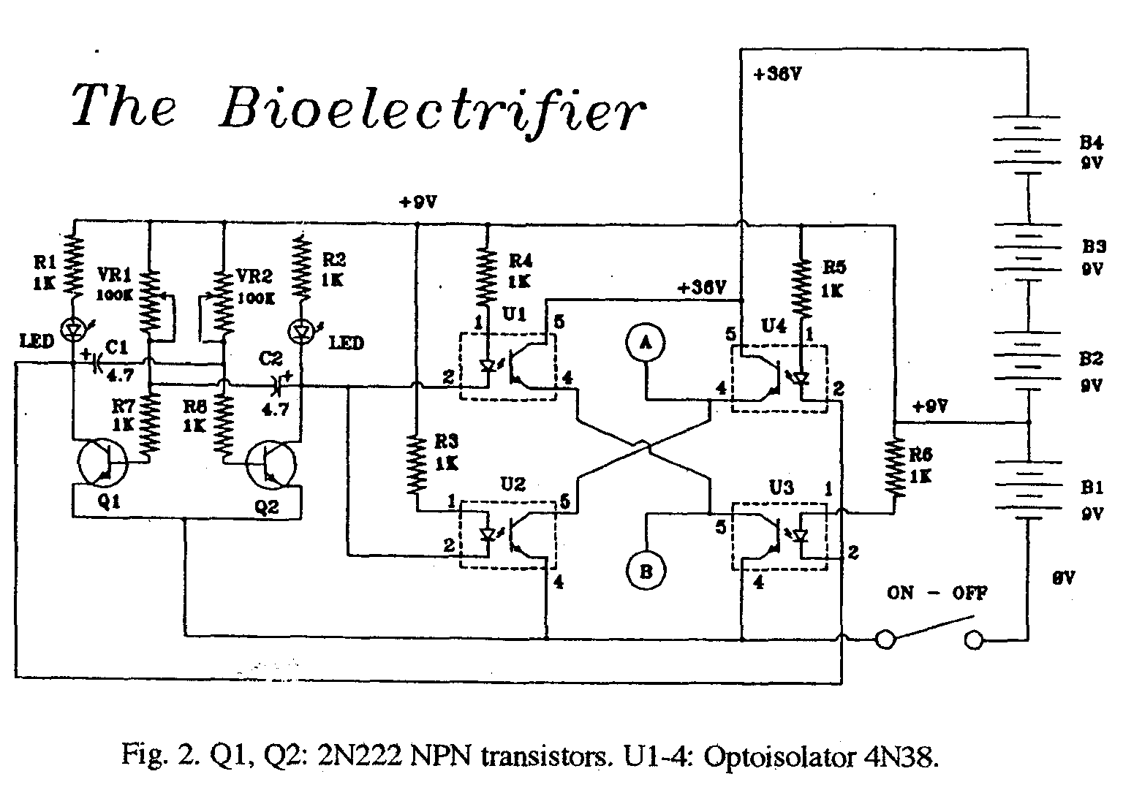

Parts List:

The Printed Circuit Board

Part Mouser # R-Shack #
When designing a printed circuit 2 transistors 333-PN2222 276-2009
board for this type of project, a com 4 Optocouplers-512-4N38
promise must be made between size and 2 LEDs- 351-3001 276-026
ease of construction. The board should 1 Dual pot- 31VA501 271-1732
be single-sided with as few jumpers as 2 4.7uF Caps. 140XRL16V4 7272-1024
possible, and there should be enough 8 1K resistors 299-1K 271-1321
room for 1/4 watt resistors, in case the 1 9V snaps-12BC310 270-405
smaller 1/8 watt are not available. The 2 "N" holder-12BN510 270-405
final design is shown in Fig. 3. Box - switch-batteries-etc

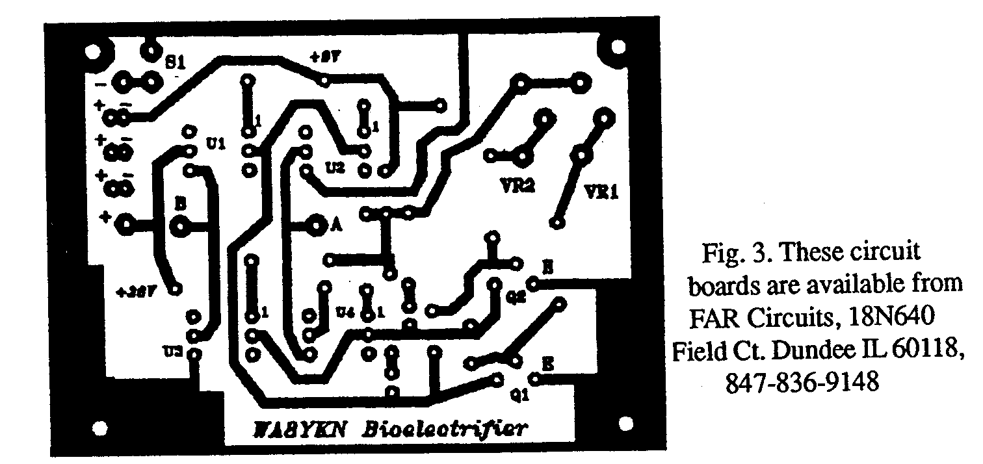

With four optocouplers in the output of our device, all that remains is to alternately drive them in pairs. The simplest circuit to accomplish this is the multivibrator -nothing more than two general-purpose transistors, two resistors, and two capacitors. Voltage is not at all critical, and since we will be connecting batteries in series to get 35 volts, we can tap off at the 9 volt point to power the circuit. While we're at it, adding two more resistors and two tiny LED's will give a visible indication of circuit operation and warn us when the battery goes dead.

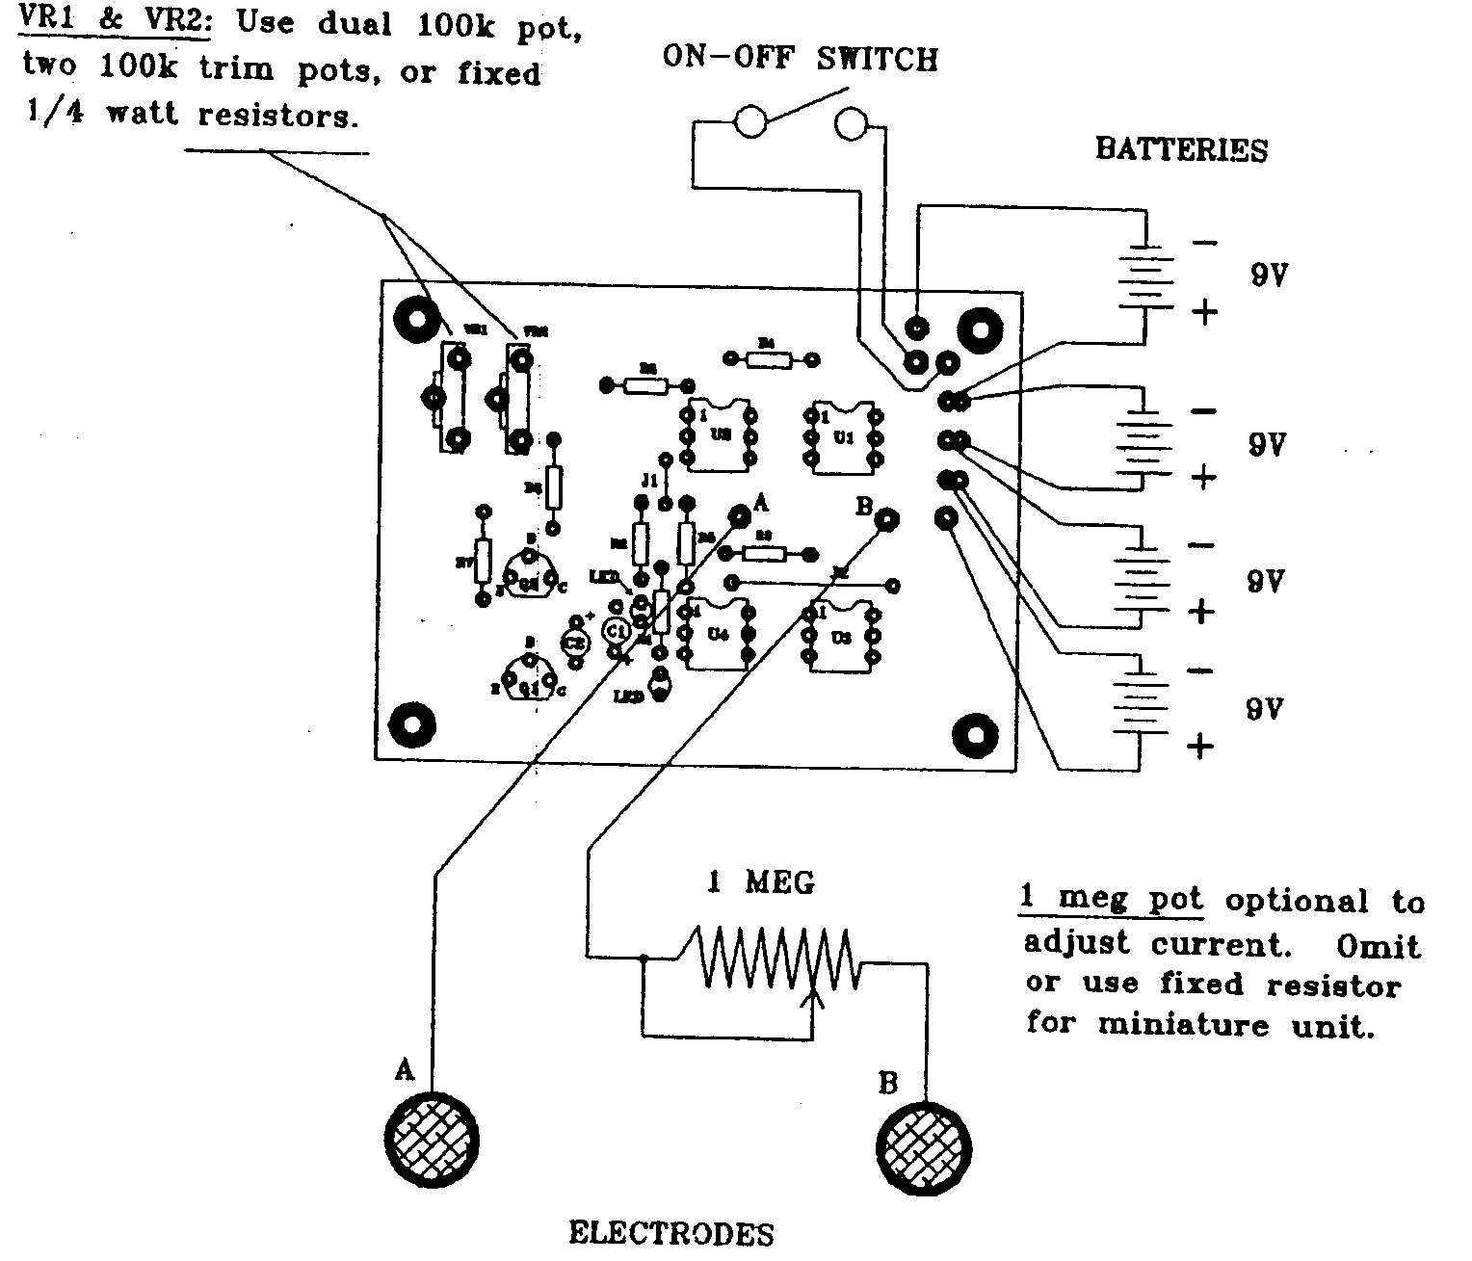

Varying the frequency of a multivibrator requires that two resistors be varied together... no big deal. Two-gang potentiometers are ideal for this. In fact, our design goals do not specify that an equal duty cycle is required, or even desired. Two trim pots will give independent adjustment of the two states if this is needed. A fixed resistor in series with each pot will establish a maximum frequency limit, preventing the circuit from dropping out of oscillation when the pot is adjusted all the way.

We now have the basis of a simple, practical design-four optocouplers, two transistors, one dual pot, two capacitors, two LED's, and eight resistors, all of the same value! The schematic diagram is shown in Fig. 2. Of course, we will have to add a box, .Switch, and batteries, and some sort of electrodes. We want to use commonly available parts to simplify the project. All of those used are available, at this time, from Mouser Electronics.

Building The Blood Purifier

Fig. 4 shows the parts layout for the Blood Purifier. Be sure to install the optocouplers correctly. Also, the very small LED's often do not have a flat spot to indicate the cathode, but instead has one lead shorter than the other. Check before cutting the leads! The long lead connects to the dropping resistor.

There are two ways that this circuit can be built. For experimentation, the device can be mounted in a larger box, and potentiometers used to vary the frequency and current, and perhaps even a microammeter to monitor the current. However, I've discovered that its not always wise to give a device with many controls to a non technical person, especially if changing any of the adjustments would nullify the experiment. Also, we want a pocket-sized device, or one that can be, clipped to the belt. Once the operating parameters are established, the resistance of the potentiometers can be measured and the pots replaced with fixed resistors. (I used 68K.)

This makes a much smaller package possible, with only a single on-off switch and two tiny LED's on the outside. I built one in a 2 7/16" by 5 1/16" plastic box (Radio Shack 270-233) and mounted the switch and LED's in the end. Four 9 volt batteries would not fit in this box, but one 9 volt and two 12 volt "N" batteries will fit with no problem, and gives 33 volts. Radio Shack sells 12 volt alkaline "N" batteries in a package of two, (23-154) and "N" battery holders (270-405). 1 made a belt clip from a strip of steel banding material and glued to the back. I also glued a two-pole terminal strip to the end of the box to connect the electrode leads, although a plug and jack would be fine. I used what I had on hand.

Editor's note: Miller tested his unit using aluminum foil strips around each ankle. The direct contact of metal to the skin can cause some burning, so a far better system is to solder the two electrode wires to some two-inch lengths of #10 bare wire and then cover them with a layer of flannel, tied on with silk thread. These electrodes can be dipped in a salt water solution to make them conductive. Then place the electrodes over the two arteries on one arm just above the wrist. You'll see a drawing and get more exact instructions on electrode placement later.

A Surprise!

When the first phone call came from a chap with emphysema I was surprised when he said that before using the Blood Purifier he could hardly get up stairs, it was so difficult for him to breathe. I'd watched my dad die of emphysema, so I knew what he was saying. But now he says he can run up and down stairs without getting winded, and he's even been out shoveling snow! As I've said, the immune system can work magic when allowed.

Ok, It's Done. Now What?

Even if your doctor doesn't know anyone with the HIV virus, there are many experiments he can try with the blood purifier. It reportedly works on the HIV virus and others, such as those responsible for herpes, Epstein-Barr, colds and flu, A few minutes a day is reported to actually prevent colds and flu.

It is interesting to note that all animal life on earth has evolved in the magnetic field of the planet. Blood, being mostly water and containing salts and iron, must generate a tiny voltage as it moves through this field. Is this voltage necessary for good health, and can it be disrupted by exposure to much more intense 60 Hz electromagnetic fields?

I've often wondered, as we think about manned missions to other planets, if we will one day discover that we cannot live for a great length of time without the Earth's magnetic field. So far, only a few people have ever left the planet, and only for a short time. These astronauts, however, have found that after a few days in space, their immune system starts to shut down! No one has yet found a good explanation for this. Perhaps a small application of bioelectrics is in order!

One interesting result reported by Wayne Green was that when his friend Beck used a similar device for two hours instead of the usual 20 minutes, just to see if there might be any harmful effects, he started losing weight! The weight loss continued until he reached his normal weight, then stopped. Since, as Wayne has repeatedly noted, far too many hams appear to be "eleven months pregnant," this could be the biggest thing since FM!

All kidding aside, there have been enough results from experiments to date to warrant serious study, and, as usual, mainstream science will continue to Ignore it, while sucking up government funds for expensive and ineffective research. But breaking new ground is the amateur's forte. We have the technical skills and the manpower. Keep in mind that every new field is pioneered by amateurs ... since the professionals do not yet exist!

One final caveat. do not build Blood Purifiers and sell them as medical devices! This will surely bring unwanted attention from government agents with nothing better to do than make your life a living hell. After all, these days even the U.S. Department of Health and Inhuman Services has a S.W.A.T. team! So build it, work with a doctor to experiment, and make sure to keep carefully encrypted records. Don't even give them away to others who want to try it, but don't have the skills to build it for themselves, unless you have no qualms about opening yourself to almost unlimited liability. Remember, the FDA and several other government agencies have unlimited funds to persecute you, and they love nothing better than the slightest excuse to appear to be working. The last thing you need is to get the attention of the bureaucrats, who would probably protect the interests of the drug cartel by outlawing bioelectricity, requiring us all to wear grounding straps on our behinds.

Note: Miller no longer will provide circuit boards, having been warned by the FDA to decease in this service. Miller has no products to sell.

The Electrode
Wrist Placement

Following Beck's instructions, here's where I've found to be the best placement for the blood purifier electrodes. If you can interest a doctor in experimenting with this device he'll probably need some guidance.

About 1 up the wrist from the palm of your hand on one arm place two flannel-covered bare #12 wires 1" long about 3/4" ± apart. This should put them right over two arteries. Hold them in place with an elastic strap. Soak the flannel in salt water every 20 minutes or so to keep it conductive. When you have the electrodes correctly placed with one over each artery you'll feel a thump-thump as you turn up the voltage control. Please don't ask whether the electrodes should be cross-wise or up and down the arm, unless you really don't know that your arteries go up and down your arm. This placeMerit avoids any possible problems with feeding the current through the heart. It also frees you so you can move around and do things.

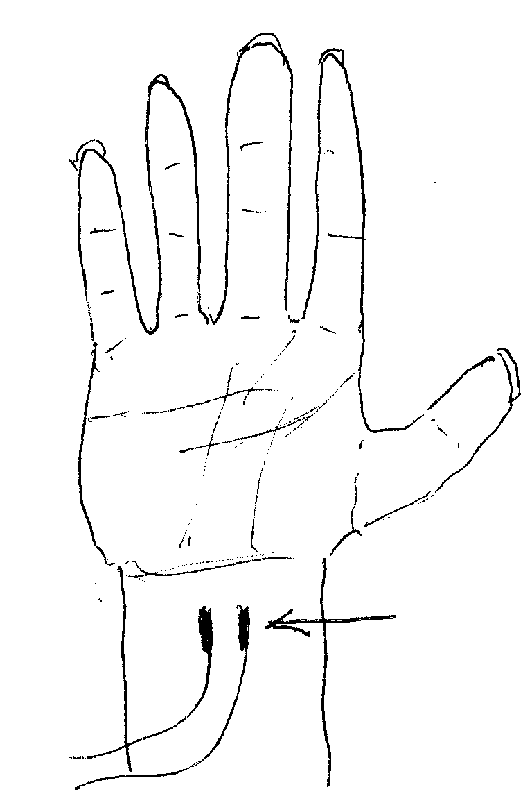

I carry my unit around in my jacket pocket while using it, making it easy for me to work with my computer and move around.

Your arteries are there, you just may have some trouble finding them. Hunt around for maximum "thump." No, your veins are not your arteries. Do not let the bare metal touch your skin -it can burn.

I look on the blood purifier (yes, I'm repeating myself) as a repair system to fix the damage I've done to my body through a combination of poisoning and poor nutrition. Yes, I drank diet drinks with aspartame for a while. I had many inoculations. I had a bunch of amalgam fillings and root canals. I drank pasteurized milk. I ate all kinds of sugar products and candy. I loved Danish and doughnuts. I gobbled down tons of ice cream. I wore dark glasses when in the bright sun. I didn't get any exercise for years. I had enormous psychological stresses (would you like to imagine the stress that finding out someone you'd trusted had stolen $100 million from you would create? I sure wish I was exaggerating!). Two divorces. I drank heavily chlorinated and fluoridated water for years, though only a fraction of the quantity my body needed. And I was fat. My immune system has its work cut out for it in rebuilding the damage I've done.

If you get the nutrients your body needs and avoid the poisons, which are all around us, you won't need a blood purifier. You won't need any doctors unless you have an accident, You just aren't going to get sick. Your immune system will fight off all invaders. It'll fight, off cancer, the bubonic plague, and almost anything else.

So start doing your homework so you'll know how to keep your body healthy. The next step is the real bitch, and that's applying what you've learned to yourself. It goes against everything we've been taught. Managing to avoid sugar and white flour products is very difficult. Just take a look into the supermarket baskets as people check out and see what absolute garbage they're feeding their families. No, they don't want to hear anything from you about it. Just shut up and check out your fruits and vegetables. Organically grown is better than not, but even with those you're still going to have to take added vitamins and minerals. I'm still researching this mine field.

The most promising stuff I've found so far is Nature's First Food from Nature's First Law, Box 900202, San Diego, CA 92190. Phone 800-RAW-FOOD - www.rawfood.com. It's got a ton of the minerals our bodies need, all from organically grown plant derived sources. I mix a heaping teaspoon of the green powder with apple juice every morning. I use a little electric hand mixer.

My fridge is filled with chopped veggies, a big bag of salad greens, my grandmother's cold slaw sauce, oranges, grapefruit, grapes, Granny Smith apples (three a day), and some raw liver which I just barely cook on the outside, and some curried chicken thighs (skin and fat removed). There's some tomato juice nice and minced garlic, which I chug down with a heaping teaspoon of cayenne pepper every morning, along with my supplements. Oh yes, some cottage cheese and red grape juice to go with an ounce of flaxseed oil every day.

Try out the blood purifier and keep track of your ailments. Let me know of any progress or lack of it. Who knows, with a sheaf of reports I might be able to get a ham friend of mine, who runs one of the largest research hospitals in Canada, off dead center. Probably not, 'cause if his hospital ever did prove the blood purifier to be effective the medical industry would burn him at the stake.

But by far the most important message I have for you is to start changing your lifestyle-what you eat, drink, and breathe. Stop wasting your life with ridiculously self-indulgent amusements and start educating yourself. My Secret Guide to Wisdom is a good starter and beats the hell out of sitting and watching ballgames and drinking beer.

Also, please stop wasting your life. working for someone else! You'll never make much money that way. And money, while not a great goal in itself, buys you freedom. We talk a lot about freedom and even fight and die for it, but then we let it slip away via our state and federal legislatures, and our activist courts. We slowly lose it through our own ignorance, inattention, and inaction.

Step one: find out the facts. Step two: do something about it!

I've done a lot of the research for you and will, given a chance, help you at least understand what I've learned. Further, I've a bunch of proposals for helping to solve our more serious social problems, almost all of which have been caused by our beloved government.

A Late Report

A doctor, who has been testing the blood purifier, reports that he found his blood temperature was being raised about two degrees while using the unit. He checked this on several of his patients and confirmed that this is a normal reaction. This could help get rid of pests in the blood.

It has now been confirmed that the purifier also has been having enormous success with cancer. My theory that the strengthening of the immune system is responsible for this has been supported by several doctors.

The fact is that when your immune system is strong the illnesses that are going around go around you. And once you've beefed up your immune system your body can get busy repairing the damage you've done. Of course, if you insist on continuing to poison your body, then you'll have to live with the painful results. At least, now you know what the poisons are, so you can't plead ignorance.

Virtually all illnesses are caused by our lifestyles. It's like trying to find an herb, vitamin or drug to make us sober, even though we continue to drink alcohol. If you stop drinking, you'll sober up. If you stop making yourself sick, you'll get well and pills are only going to ease the symptoms caused by our lifestyles.

A Little More On Silver Colloid

There is so much to write about this that I'll eventually have to do a separate report. But just using three 9V batteries (27V) and sticking two five-inch pure silver #10-sized wires at room temperature in an 8-ounce glass distilled water for 10 minutes should give you about a 10 ppm solution.

Store it in a dark brown bottle so the light won't react with the silver. You can rinse your chicken, fruits and berries in it to kill salmonella, E. Coli, and so on. It's great stuff. Beck says you can even drink it. Douglass says not to, but I've letters from several readers who have been taking from several teaspoons to eight ounces of it a day and say it has been doing wonderful things for them.

You see, microbes need oxygen to live and the silver stops them from getting oxygen, so they quickly die. And it is ridiculously easy to make. By the way, if you have any problem finding pure silver wire, I have a roll of it and I'll send you a couple of 5-inch lengths, which should last you several years, for $15. This is pure silver #10 wire (about an eighth of an inch thick!).

A couple grains of salt will speed up the silver colloid generation, but even without any salt you'll see the smoke-like silver coming off the wires.

Scorch says: “DO NOT USE ANY SALT to speed up the process! This will make silver chloride! The solution should have the appearance of tea. Darkness depends on concentration and it can take longer than 10 minutes. If it is white or clear? You are not doing it right!”

In making future batches, instead of salt, you can get the action started more quickly by adding a few teaspoons of silver colloid from a previous batch to your distilled water. If you use too much salt you'll be making some silver chloride along with the colloid, and that could cause some permanent skin discoloration (argyria) and you could easily be mistaken for an ET.

Scorch says: “DO NOT USE ANY SALT AT ALL!”

(SEE: http://colloidalsilver.hypermart.net/silver/article2.html)

I (Wayne Green) published an article in the April 1997 issue of 73 magazine on a silver colloid maker, so if you're handy at the workbench you can splurge $5 and get a reprint of the article. It's by Tom Miller, the same chap who wrote the blood purifier article you've just read. This silver colloid article explains the background of silver colloid use, and has the circuit for a constant-current colloid generator (the best kind). Plus, he has a circuit for a unit which will check the silver concentration. The Silver Colloid Generator reprint is $5 and is my catalog number 98.

Questions

I'm often asked if the Hulda Clark "Zapper" is the same as the Beck Blood Purifier. Not even remotely. While the blood purifier is based on reliable scientific theory and research, there is no theory to explain why the Clark Zapper should do anything more than excite the placebo response. If you believe it will help, then it will. Nor is there any evidence to support Hulda's theory that liver flukes are the basis of most illness.

And, with all due respect to Royal Rife, I have yet to see any reliable research reports confirming that any of the so-called Rife generators now being sold have any scientific validity. I would expect that in the 75 years since Rife's work that there would have been some published validation.

The $155 Butterfly Products Plant Growth Stimulator (PGS), when used as a blood purifier, has been, working miracles, with sales spreading like wild flowers to the families and friends of the buyers. Many owners have been getting second and third units, often to help parents with serious illnesses.

If you have a friend or family member who has made themselves sick, either directly or, more likely, through damage to their immune system, thus allowing opportunistic diseases to overwhelm their immune defenses, and have done this by a combination of lousy nutrition, poisoning their body with stuff like cooked food, mercury (amalgam fillings), root canals, alcohol, sugar, white flour products, nicotine, aspartame, smog, caffeine, immunization shots, fluorides and chlorine in their water, dehydration (not drinking at least a half a gallon of pure water a day), stress, a lack of exercise, or too little time in the sun, then they'll be looking for the usual fast fix for their years of neglecting their body. The blood purifier does seem to be doing the job as far as cleaning viruses, microbes, parasites, yeasts and fungi out of the blood, thus allowing immune systems to rebuild themselves.

Unfortunately there are no FDA approved devices available, so the manufacture or sale of blood purifying medical devices is illegal and can bring FDA swat teams and long prison sentences into play. On the plus side there is a Plant Growth Stimulator which can be adapted by the experimentally minded. Doctors may legitimately use the device for research purposes, providing they make some minor modification. Such a unit is available from Butterfly Products, Box 1729, Hillsboro NH 03244 for $155, including s/h (in the US). Make checks or MO out to Butterfly Products. MC and Visa are accepted. Phone: 603-588-2105.

In the long run, it is infinitely better to stop abusing your body than to keep treating the symptoms your neglect and abuse has caused. Just take a good look at the stuff in your shopping cart before checking out at the supermarket. You are eating this junk and feeding it to your family. Worst case: your doctor is waiting for you with an array of drugs, all of which have interesting side effects, none of which are beneficial, or even interesting serious poisons like chemotherapy, heart by-passes, and other expensive surgery. And your dentist is waiting with a smile to put mercury into your teeth for you. It's your choice. Dental problems, by the way, are normally the first indication that your body is starting to break down. You can find out for yourself what your body needs for proper maintenance, and thus add at least 20-30 years of good health to your life, just by reading some of the recommended books in my Secret Guide to Wisdom and my Secret Guide to Health.

All other animals live between ten and sixteen times their age at puberty. We would too, if we didn't continuously poison our bodies. Parents are really difficult to reason with, when it comes to their health. They've been brainwashed twenty-some years longer than you about the safety of our food supply and the value of doctors when something goes wrong. The concept that they should have been eating raw food, that sugar is poison, and that doctors have been doing whatever it takes to keep us in the- dark as to the cause and cure of almost any disease is a tough sell. But, when cancer strikes, or a heart attack, that may be enough of a shock to get their attention. By then you may be able to get them to read my health guide. Probably not.

If you've screwed up your body so badly it has AIDS you need to immediately read the colloidal silver book by Dr. Farber, the book by Dr. Comby on diet, the videos from Dr. Day, the book by Arlin, Dini and Wolfe on raw food, and get a blood purifier. If you have given yourself cancer, read Farber, Comby, and clean your blood. If you are not drinking at least 8 glasses of distilled water a day you are at the least foolish. It's time to do your homework, because I guarantee that your doctor hasn't. He believes what he was taught in medical school and what the pharmaceutical company salesmen tell him-and bribe him to prescribe.

The reports from blood purifier users are awe inspiring. But then, your body's immune system, if kept strong, has incredible powers to repair damage. There are even reports of it being able to rebuild damaged lungs and bones. With a strong immune system you are not going to get anything "going around." You'll be able to walk through a room of coughing TB patients and not get anything. The blood purifier could be the answer to the AIDS and malaria epidemics in Africa.. Dr. Beck has endless confirmations of AIDS cures using his purifier.

If any of the bioterrorism threats are carried out, the blood purifier could be a life saver for you and your family. With an industrial strength immune system you aren't going to be knocked out by anything as puny as an anthrax or smallpox attack. Or even the WWI flu that killed more people than the war did, should some vindictive rogue nation or angry militant group decide to use this inexpensive way to attack The Great Satan's citizens (and a few million illegal immigrants).

Meanwhile ......

In the meanwhile keep after Art Bell to have me on his show more frequently (artbell@mindspring.com). I've got a Iona, list of things to talk about-my WWII submarine experiences (you'll enjoy my $5 book), where I was in the right place at the right time to save the boat from being sunk. Twice! Or my book describing a bunch of ways you can enormously improve your state government. How about my book on the several predictions on the coming human extinction events? Or Moondoggle, my book which explains how I came to be convinced that all of the Moon landings were a hoax. Or how people with gardens or farms can increase the growth of their produce by at least five to ten times, and make sure that the trace elements now missing from our commercially- grown produce are in their plants. Or about how valuable it will be if we get kids started learning about electronics, radio, and computers starting around the eighth grade. Or the fun and adventure amateur radio can provide as a hobby. It's provided me with a lifetime of adventure, friends to visit in countries all around the world, and ham buddies to ski and scuba dive with. And write the producer, Alan Corbeth, c/o Premiere Broadcasting, 540 East Vilas Road #C, Central Point OR 97502.

Wayne Green

Box 360 - Hancock NH 03449
603-588-0107 - fax: 588-3205 a, www.waynegreen.com - w2nsd@ao1.com

