MAJOR EAR POINTS
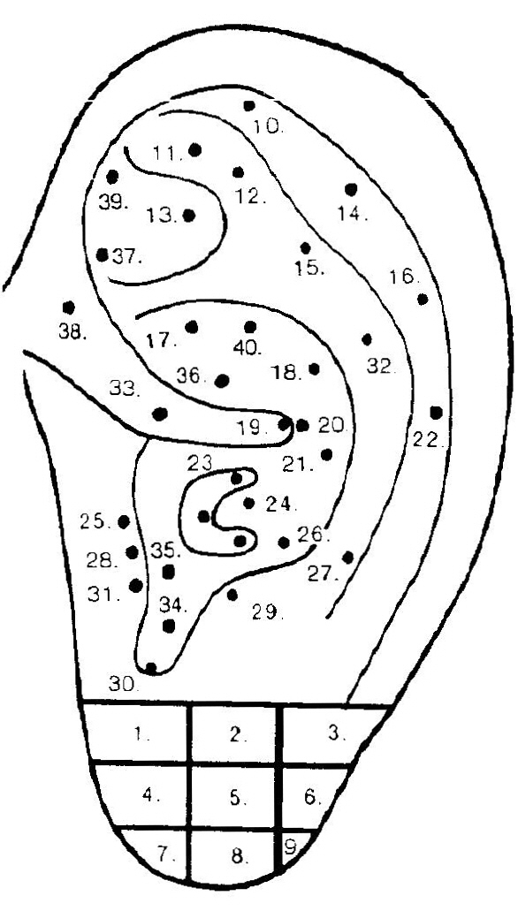 | 1. Teeth - Upper Jaw  2. Mouth  3. Jaw & Tonsils  4. Teeth - Lower Jaw  5. Eye  6. Inner Ear  7. Teeth - Lower Jaw  8. Tonsils  9. Inner Ear  10. Foot  11. Ankle  12. Knee  13. Relax - Shenmen  14. Wrist  15. Hip  16. Elbow  17. Prostate  18. Gall Bladder  19. Relax - Zero  20. Stomach  21. Liver  22. Shoulder  23. Lung & Bronchials  24. Heart  25. Nose - Internal  26. Toothache  27. Neck  28. Adrenal  29. Asthma  30. Endocrine  31. Addiction/Hunger  Tranquilizer  32. Vetebrae - Lumbar  33. Diaphragm  34. Subcortex  35. Triple Warmer  36. Intestines - Large  37. Nervous System  (Sympathetic)  38. Genetalia - External  39. Uterus  40. Kidney

