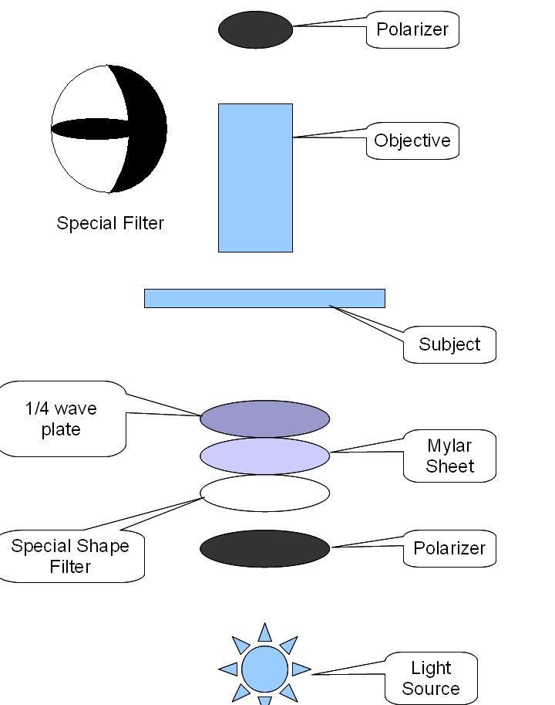

Above is the outline of the optical train with an inset of the “special filter” this filter is a combination of an oblique moon with a centrally placed ellipse. Radius of the moon 40 mm, radius of the ellipse is 42 mm. Filter is 32 mm.

Set up:

- 1. Focus on subject
- 2. Cross polarizers so that the background is black
- 3. Insert special filter
- 4. Insert mylar sheet
- 5. Focus condenser up or down until the file is just free from a quasi “phase” effect. There may be some slight darkness on the edge of the field of view. If you have a phase telescope use this to center and focus the special filter in the objective back plain.
- 6. Rotate the mylar sheet until the background is bright green
- 7. Insert ¼ wave plate and rotate until background is white (or close to it)

I have recently modified the setup. In the modification I insert a half circle mylar sheet instead of the full mylar sheet. It is oriented as below:

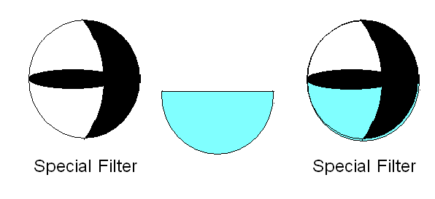

Modification Number 4

