Etherglow evaluation notes Jon Hudson

Equipment used

Wild M20 universal condenser X10 Fluotar X20 Fluotar X40 PH Fluotar

Olympus WHK 10X /20L oculars.

Leitz periplan 10X eyepiece in HUE phototube connected to Canon G2 camera.

Illumination

As Ray noted the Etherglow needs a lot of light.

My normal illumination is with a sub bench mounted K2 star LED (75 lumen max) www.luxeonstar.com/sub_category.php?id=1431&link_str=1431 incorporating a flash tube (based on Charles Krebs modified Vivitar 283). www.krebsmicro.com/VIV283/index.html

The LED illuminator at maximum brightness with the Etherglow in place did not give enough light for viewing through the oculars (The problem is compounded by the light split of 20 to 80 with the Wild HUE phototube). The flash could be set to give sufficient illumination through the photo eyepiece but of course this meant that I couldn’t focus using the oculars with the Etherglow in place.

I also have another K2 star LED illuminator at 130 lumens max which I use just below the filter holder on the condenser for darkfield work.

With this illuminator in place I was able to get enough light through the Etherglow.
Of course with this set up in place I could no longer use flash .

Tests

A. I first looked at the effect of the etherglow using a Roseoptic demonstration cylinder. www.roseoptics.com/DemoCylinder.htm

Subjectively the results are counter intuitive in the quest for correct illumination as the light is diffuse at all condenser settings (or without a condenser) rather than the precise “column like “ illumination we aim for.

B. Using Klaus Kemp’s excellent diatom test plate www.diatoms.co.uk I took the following photographs using X10 X20 and X40 objectives (all Wild).

With condenser and with / without Etherglow in sub condenser filter holder

- Flash only from sub bench illuminator. Photograph 1

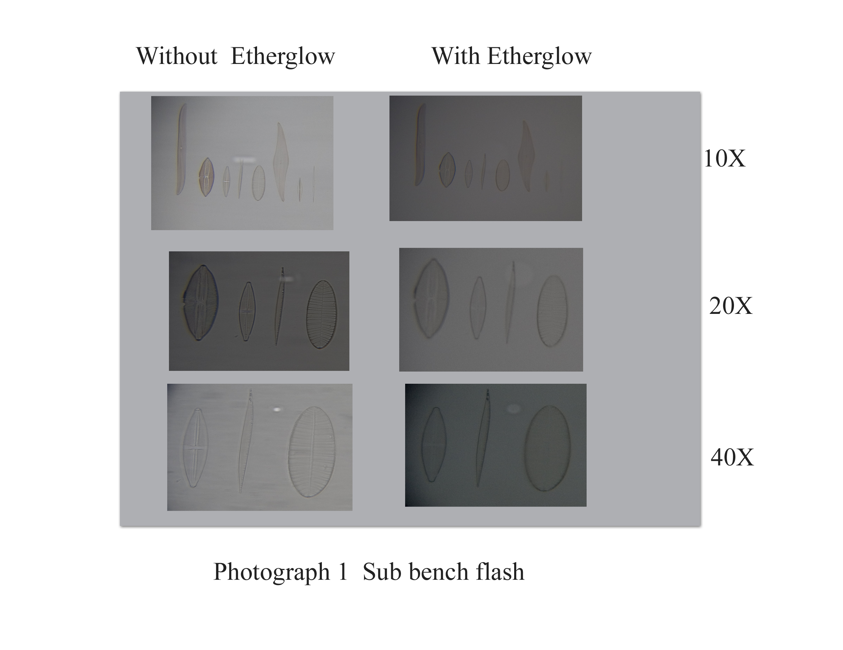
- Sub condenser 130 lumen LED illuminator. Photograph 2

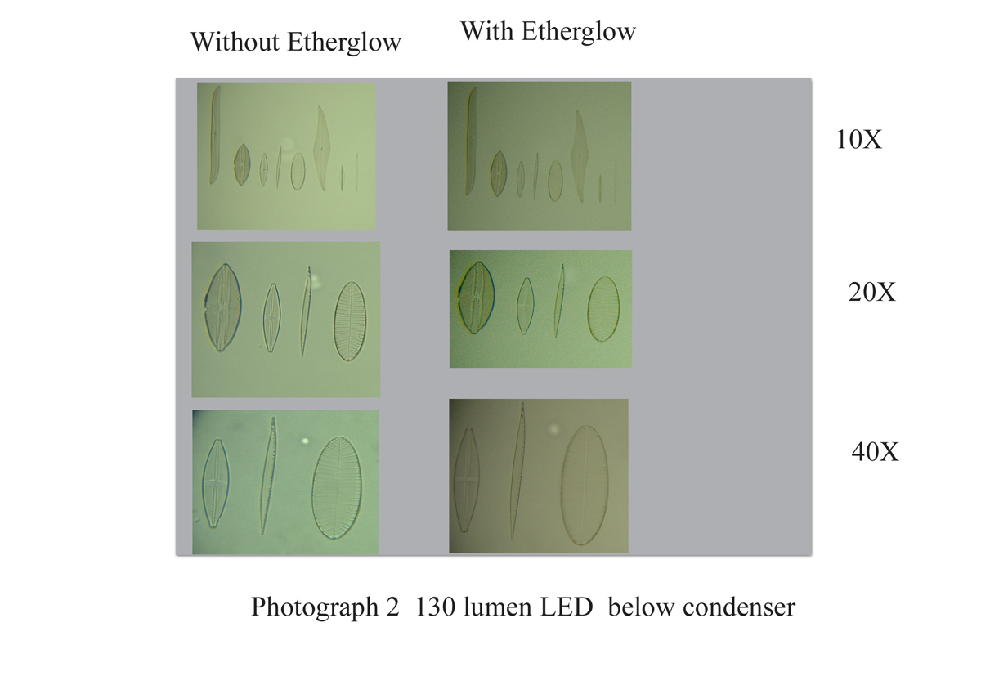
The view through the oculars showed that the Etherglow gives a nice flat and even background with little loss of detail. The photographs however show a loss of detail when using the etherglow . For the flash pictures this could be due to the problems with my set up of focusing through the oculars with the etherglow in place.

- Without a condenser in place with the Etherglow filter resting on top of the condenser holding ring 3cm below the stage the level of detail was better than with a condenser both through the oculars and in photographs. Photograph 3.

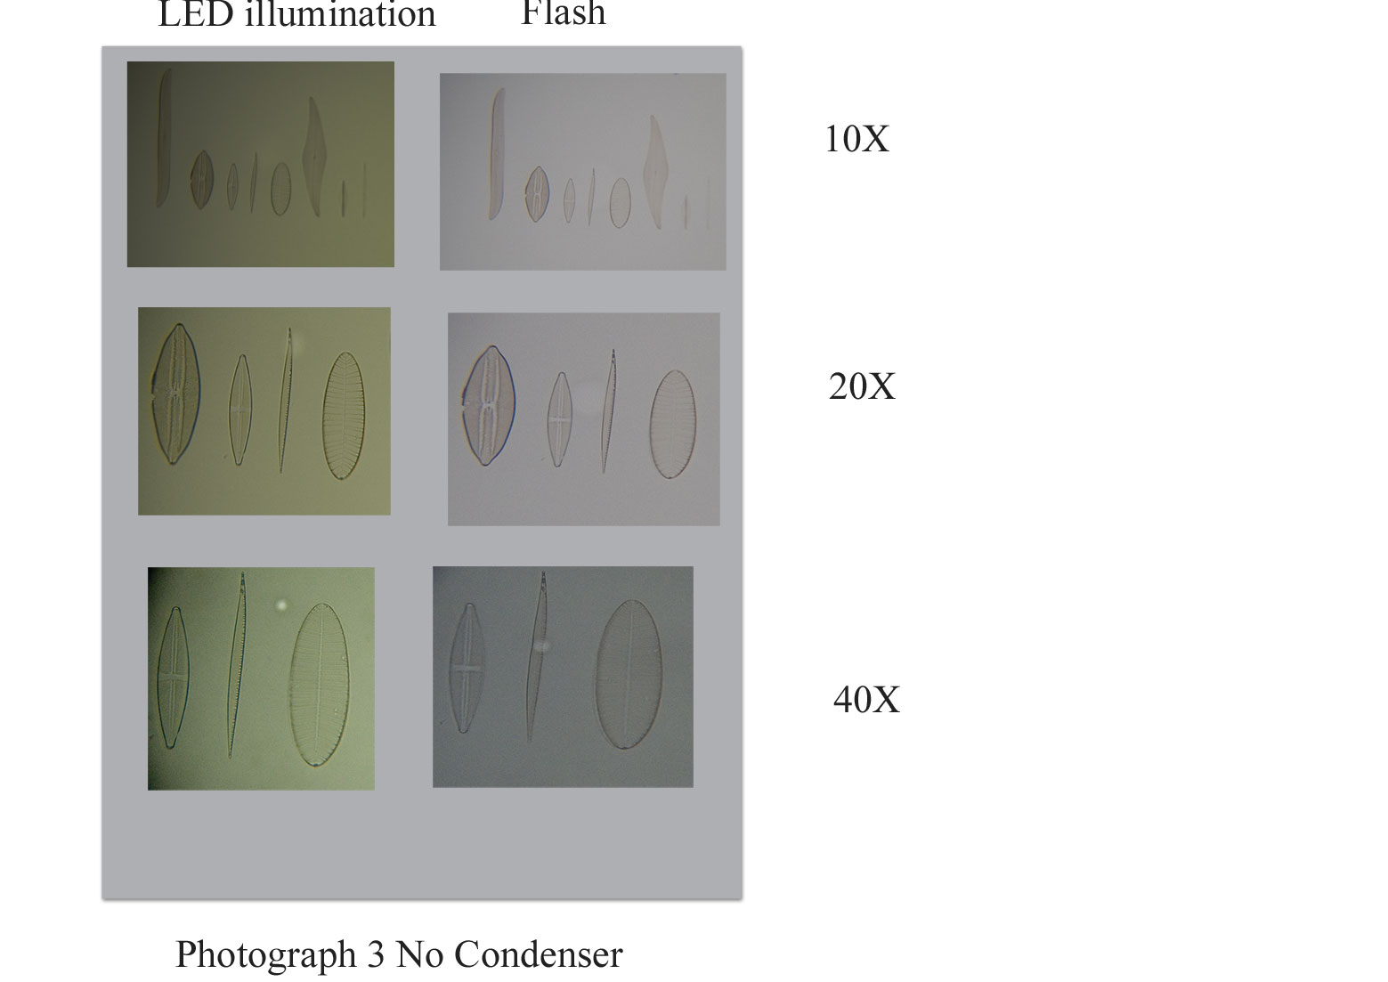

- The distance of the Etherglow below the stage did not seem to affect the results significantly.

C. Low power test

Since I rediscovered microscopy last year after more than 30 years absence I have not done any low power work. I decided to try the Etherglow with a recently acquired Wild X3 plan fluotar objective. Voila. These tests definitely show the Etherglow at an advantage.

Photograph 4.

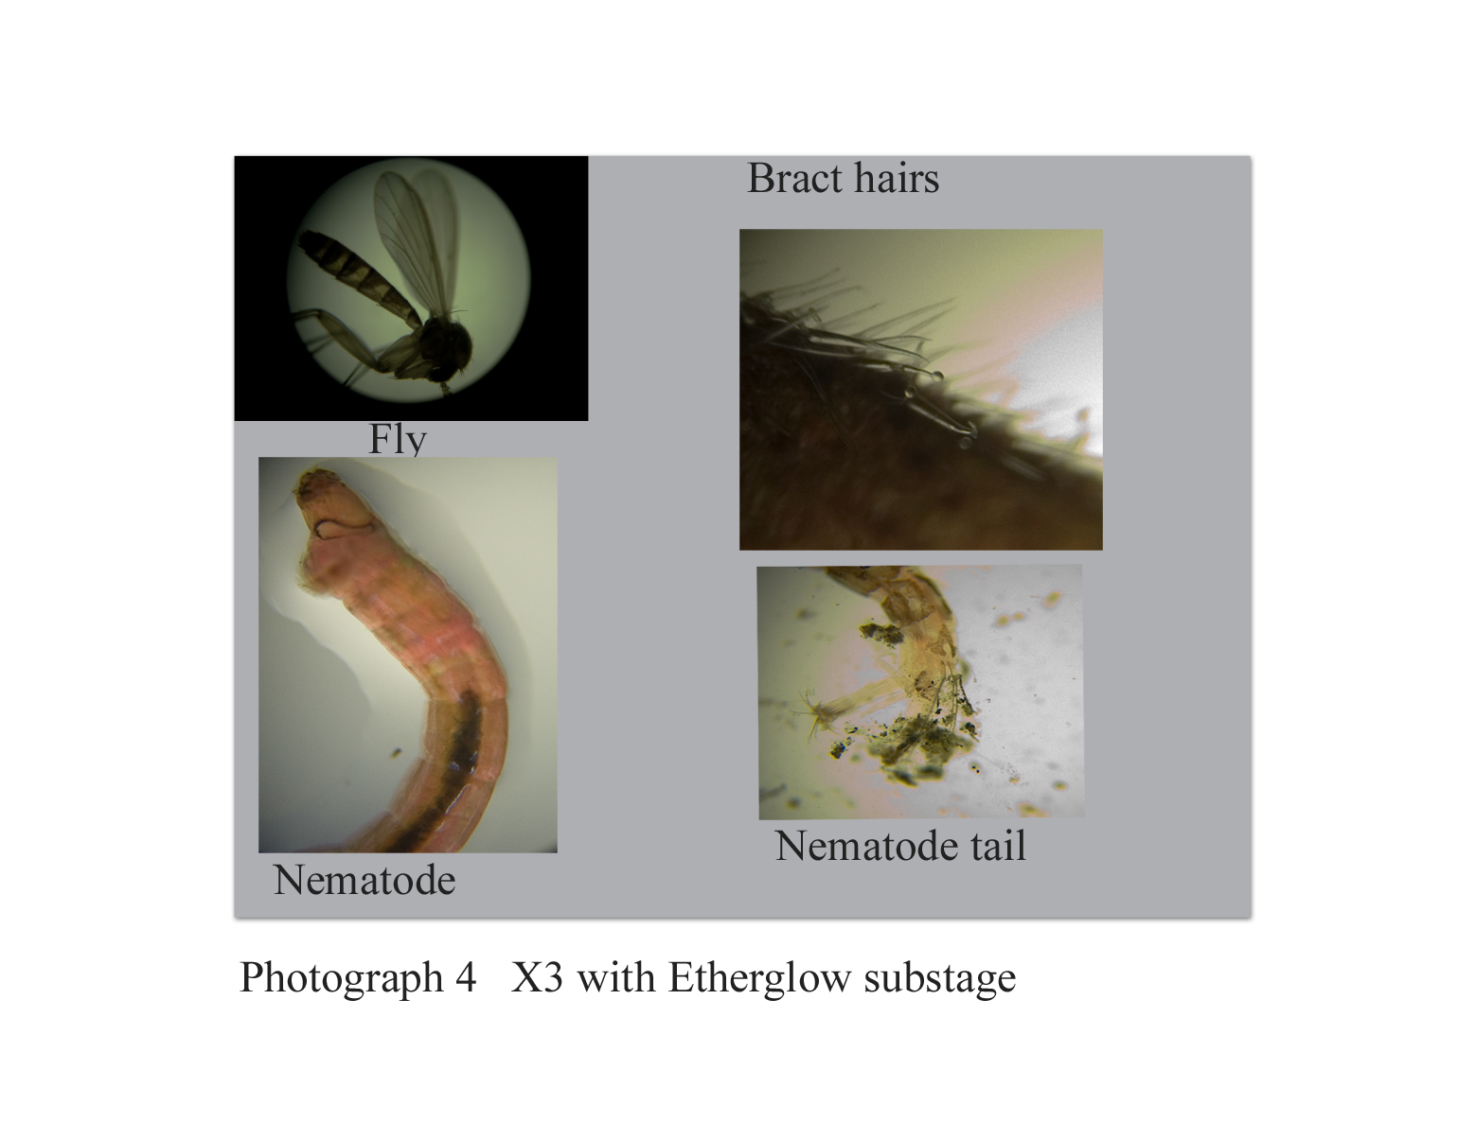

My identification is probably wrong as I have no expertise / experience in this area.

The Etherglow was set up just below the stage with the condenser removed and illuminated from below with the same 130 lumen LED illuminator as in the previous tests.

Overall conclusions

It is clear to me that the Etherglow gives good results at low magnification.

My overall conclusions are that the Etherglow offered no real advantages for me on medium power using a condenser which of course I also need to provide phase contrast and darkfield.
However I was impressed by its ability at low power and would be interested in acquiring one for this purpose when / if it becomes commercially available.

Jon Hudson 24/3/2008

