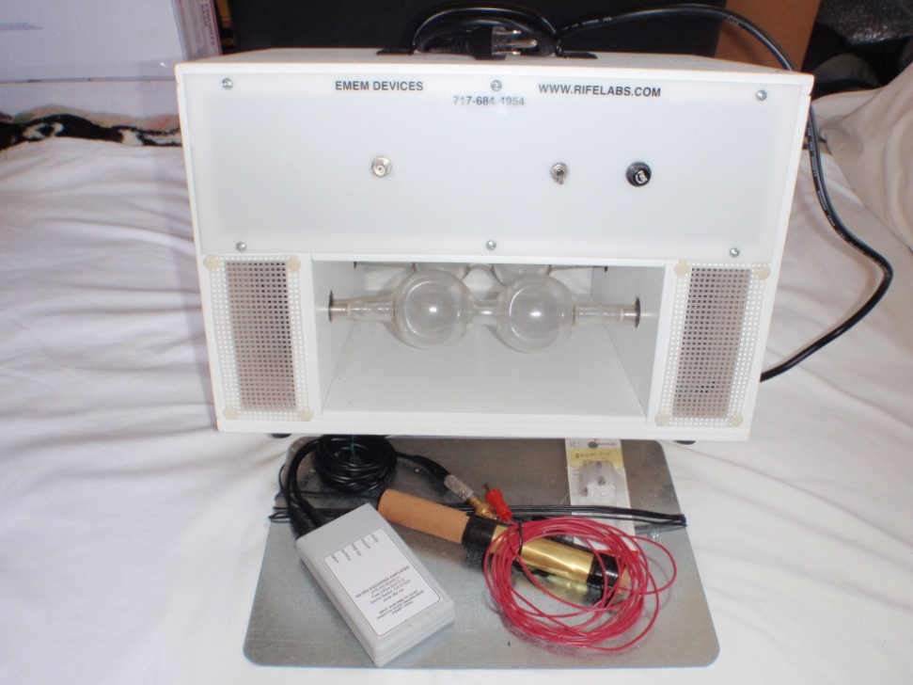

***EMEM3 Double Bubble / Double Tube Plasma Tube Machine***

**This is a one of a kind plasma Tube Machine built by Dave Nelson.**

**It has two gasses. One tube is Helium gas and the second tube is Xenon gas.**

**Also included:**

**Instructions and 2 spare fuses**

**Hand held and foot grounding plate**

**Frequency generator**

**This machine does frequencies in the Rife Range 0-10,000 Hz**

**Original Price was $1121. Selling for $550 shipping included (USA)**

**See additional pictures below:**

**Contact :**

**thomas5714@yahoo.com**

