***2-TESLA COILS FOR SALE***

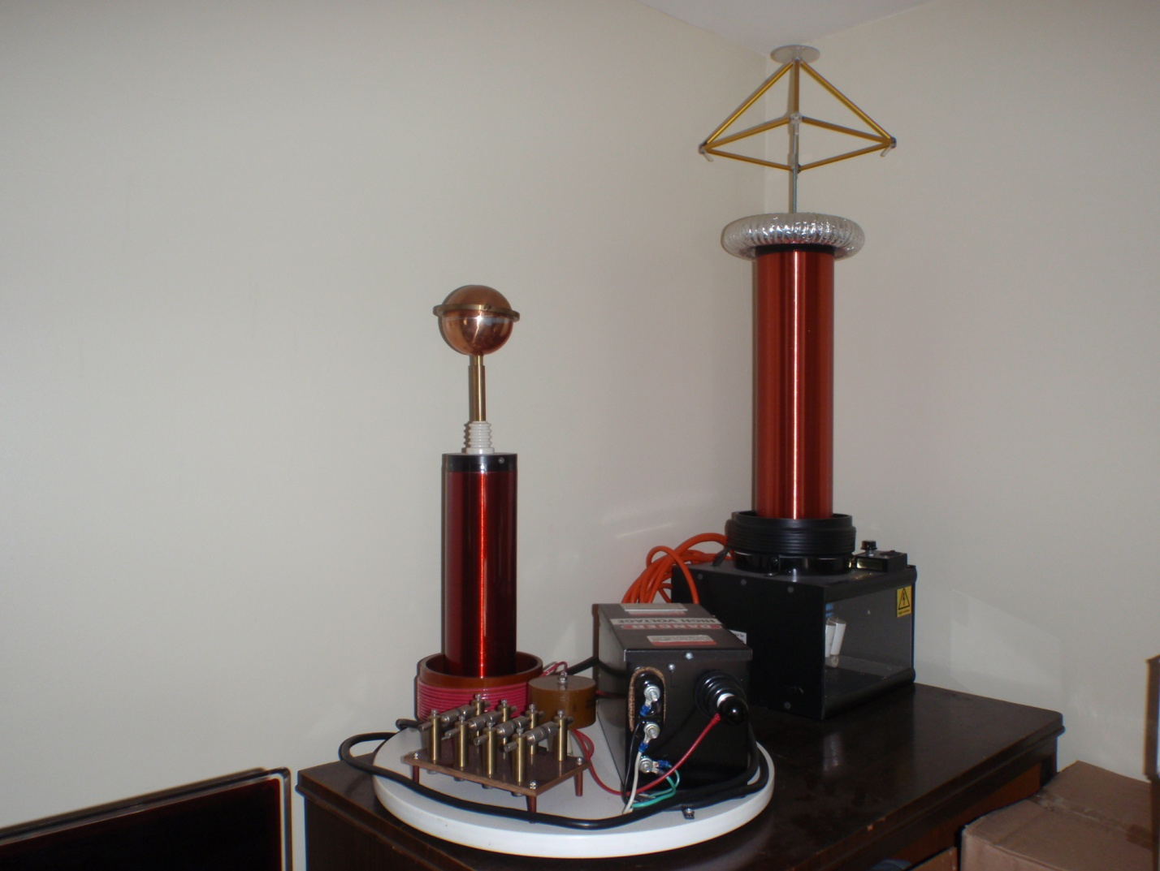

**Telsa Coil Model 1 (shorter one on left)**

**Price new is $900.**

**Will sell for $350 and shipping included.**

**See websites for more info:**

[**http://www.oobject.com/crazy-tesla-coils/tesla-technology-research-model-1-coil/1274/**](http://www.oobject.com/crazy-tesla-coils/tesla-technology-research-model-1-coil/1274/)

[**http://teslatechnologyresearch.com/model1.html**](http://teslatechnologyresearch.com/model1.html)

**Email:** [**thomas5714@yahoo.com**](mailto:thomas5714@yahoo.com)

**Here is a pictures of the Model 1 up close:**

