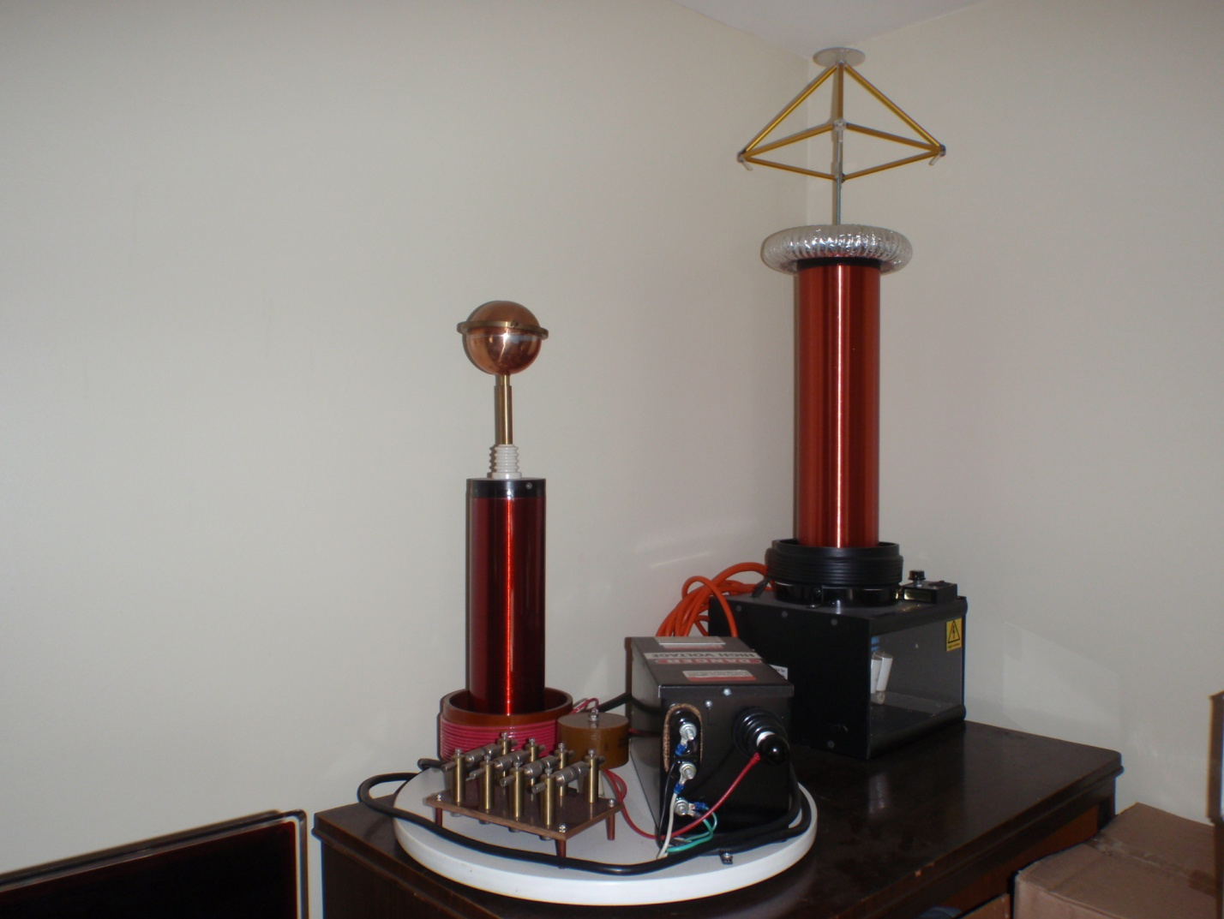

**Tesla Coil Solid State Pyramid Charger**

**(The taller coil on the right)**

**Built by Nick Edwards**

**Original price: $1600. Selling for $550 shipping included.**

**See Demo video on this website:**

[**http://www.pyramidplanet.com/pyramid-power/index.php?main_page=page&id=3&chapter=0**](http://www.pyramidplanet.com/pyramid-power/index.php?main_page=page&id=3&chapter=0)

**Email:** [**thomas5714@yahoo.com**](mailto:thomas5714@yahoo.com)

