1. Using any tape available, tape together two (2) C or D size batteries with the plus and minus ends touching together:

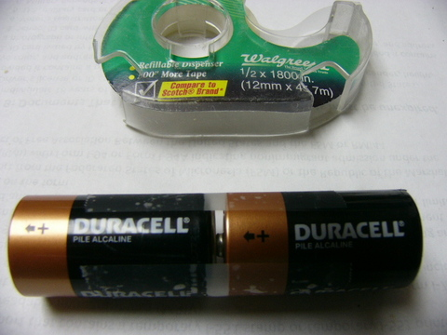
Notes: You can use either C, D, or even AA or AAA. They will not be as powerful due to smaller ends allowing less total current.

2. Each battery has 1.5 volts for standard, and 1.2 volts for rechargeables. It does not matter which kind you use:

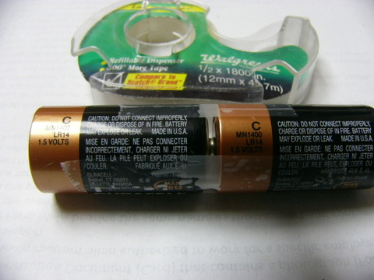

Notes: You can use any tape to hold them together.

3. Place two(2) rubber bands alongside the end and wrap around with a third rubber band. Stretch over piece of sponge. Cellulose sponges or natural, not plastic foam, they must hold water. Cloth can also be used

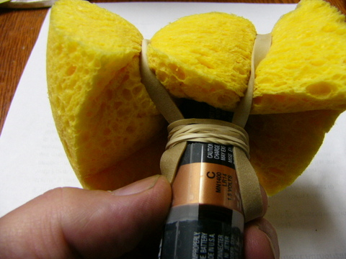

Notes: Sponges are very conductive if made from cellulose. Plastic sponges will not work, they instead tend to act as insulators allowing little or no current to pass.

4. Side view. If cloth is used, try about 5 or 6 thickness cotton cloth:

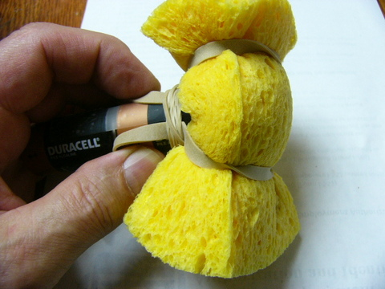

Notes: Any absorbent fiber or blend or cotton/synthetics works fine. Paper towels can be used, as well as anything hand that will absorb water. The water used can be tap water, or any other water. I would think distilled water would be less desirable since it has no minerals to carry electricity. If using distilled water you may get less power. Adding a pinch of baking soda to distilled water can “up” the power but be careful it makes things very conductive compared to most tap water.

5. This shows a completed rod. It's the same on both ends. One end will be battery (+) the other end (-):

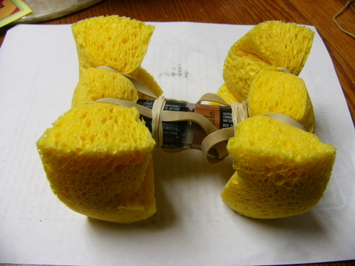

Notes: you need a sponge at each end. One goes into the hand, the other on the spot you want to research, where the germ is located. The battery should send electricity through from the hand into the body, and to the spot where the other end is located.

6. Top view. Any means of attachment can be used like tape, string, or insulated wire:

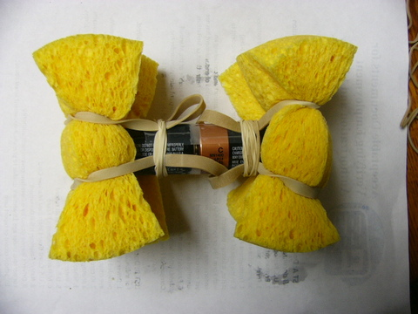

Notes: This shows one way to attach the sponges. There are probably many ways to attach them, but in all ways the sponges must make contact with the metal ends of the batteries. One is Plus, the other Minus.

7. Make 2 of them. Usually 1 is enough, but sometimes nicer and faster to use 2:

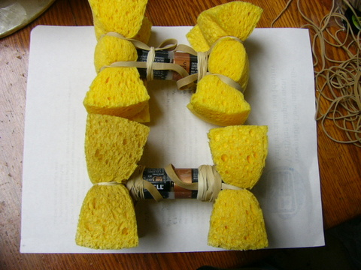

Notes: Having two rods allows you to combine them in interesting ways.

8. Author shown applying one rod to oral/nasal cavity. This is for researching one side infections. Current goes through hand and face to make circuit:

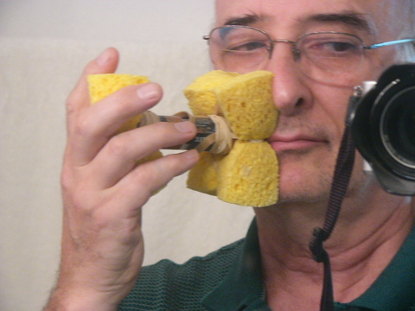

Notes: In this photo I am only touching one rod to one area. Electricity will be going into that area, down through the body, and coming out through the hand. This targets a narrow area, and avoids eyes and brain, which may not be necessary, there may be no problems with those areas, but if I don’t need to go there, I do not.

9. Author shown with 2 rods used for teeth, gums and sinus research. Current goes through hands and across and through facial area, see notes below.

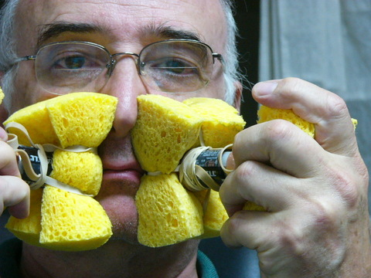

Notes: In this photo I am applying the current into the facial area of the mouth and lower sinuses. Rods are placed with one Plus on face, and one Minus on face. The current will start out 3 volts on one side, pass through the face, and add another 3 volts on the other side where the second rod is working. Both sides will be getting a total 6 volts. This only works when you have the Plus on one side and the Minus on the other side. If you have both plusses (or both minuses) touching the body, then you get only 3 volts and you do not get as much crossing of flow from one side to the other. But the current will stay lower down the face and will be slower and more gentle to use. In general if you double the power, you cut the time in half. But over 6 volts is trouble, too strong. Keep it at or under 6 volts based on the battery ratings. The actual volts applied to skin should be less than 6.

This is NOT a cure. For medical conditions consult your doctor or healthcare professional. It is for research, entertainment and study only. Nothing is for sale.

