The following pictures and descriptive text were taken verbatim from the microelectricitygermkiller Yahoo Group at:

http://health.groups.yahoo.com/group/microelectricitygermkiller/

The Paddles

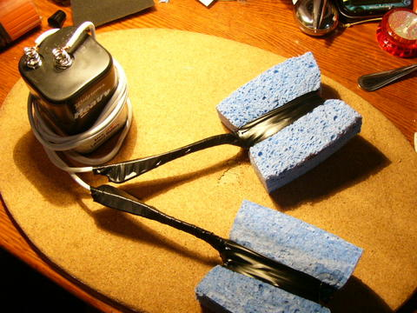
Parts needed: 6Volt battery, wire, 2 forks, big cellulose1.5 inch thick sponge, electrical or other waterproof tape
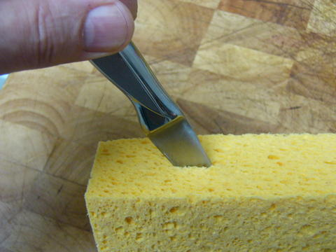
Make two cuts about 2 inches deep into side of sponge near the middle as shown. Forks will be inserted into them
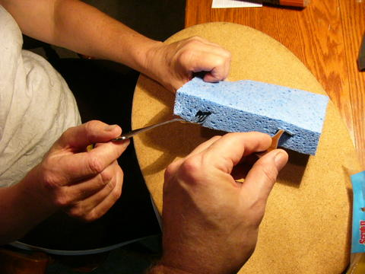
Shows where two forks go into sponge. Forks can be stainless or silver with plastic or metal handles.
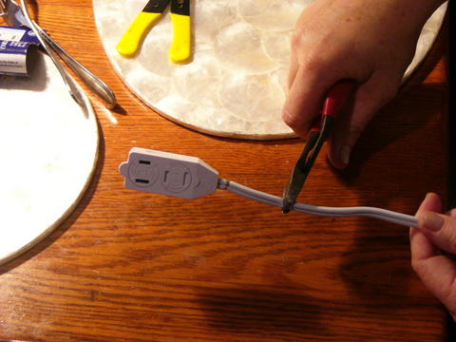
Cut off the ends of a 6 foot extension cord. (unplug it first!)
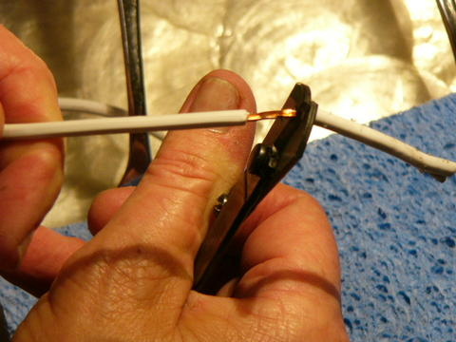
Split the wire and strip off insulation about 2 inches on all 4 ends
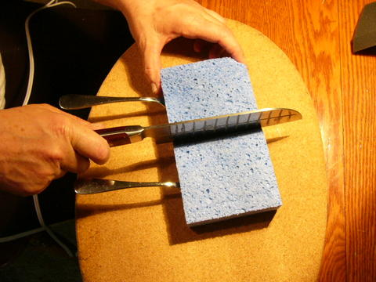
Cut the sponge in half
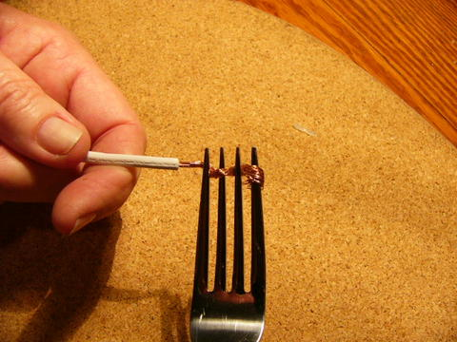
Twist the wire and wrap it between the prongs of the fork
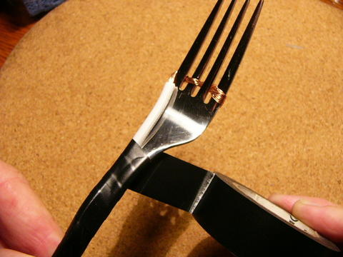
Slide the wire all the way down. Wrap fork with tape starting from the bottom of the handle going up toward the prongs.
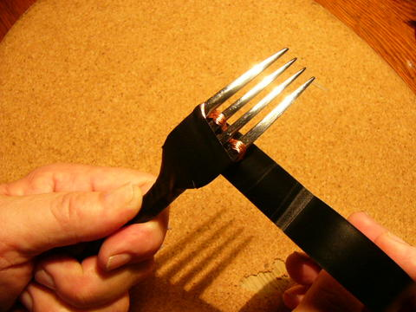
Go around the wire with the tape and keep going
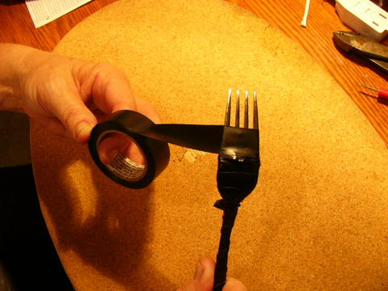
Here is where you can adjust the power by how much metal shows. More metal means more power. Less metal means less power. Suit yourself, you can always change it later by unwrapping or adding tape.
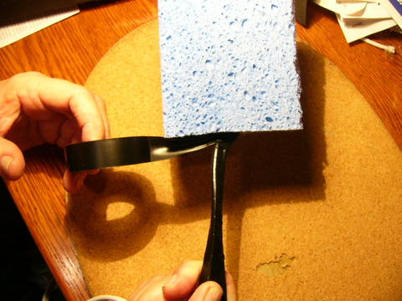
Stick the fork in all the way.
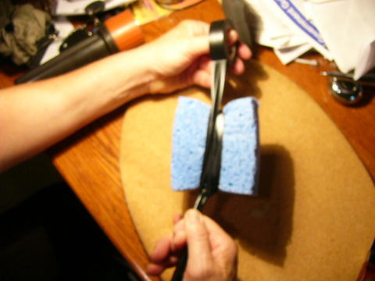
Wrap tape up over the sponges to hold them in place on the forks
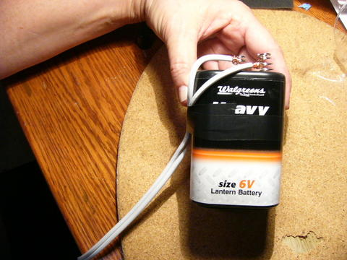
Attach free ends of wire to battery terminals by twisting wires tightly. It does not matter which goes to positive or negative. Wrap tape around wires and battery to hold wires tightly to battery
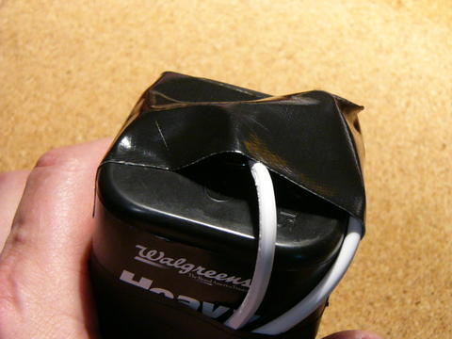
Vital. Tape over the top to ensure wires stay on and they don't touch anything. Fires or dead batteries can result if you don't do this.
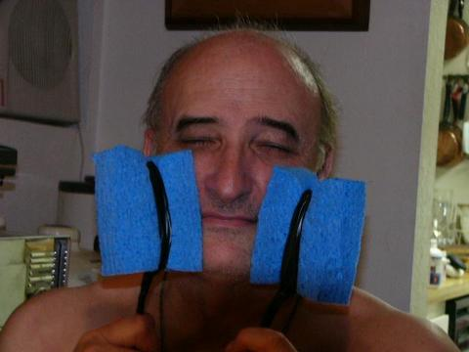
Inventor shown holding pads against face. Pads are wrung out so nearly dry. Do not use them soaking wet, it is too strong. Move them around, reverse pads from left to right every 5 minutes or so. Slight flash is optic nerve sensitivity, shows it is connected.
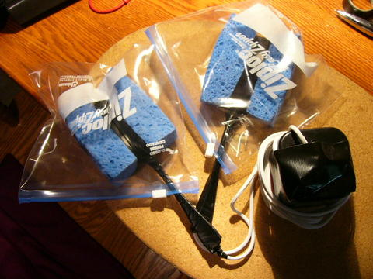
When storing, always put the pads into plastic bags to keep them from touching.

DONE!!!

