The following pictures and descriptive text were taken verbatim from the microelectricitygermkiller Yahoo Group at:

http://health.groups.yahoo.com/group/microelectricitygermkiller/

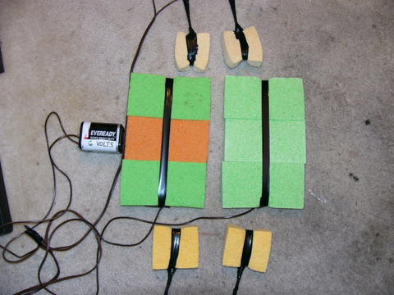
The Ultimate Godzilla

The Complete System
Everything connects to one battery. Several systems can run off 1 battery! Paddles (see our paddles photo folder) are used for both wrists and ankles when treating systemic infections. Larger pads are for intestinal area (HIV) or liver area (Hep-c). Use them all at once for whole body research in systemic infections. Use only 6 volts!

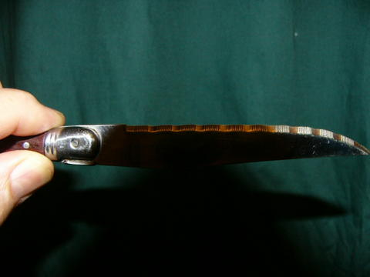
You need a sharp knife
Pointy serrated knives work best on sponges.

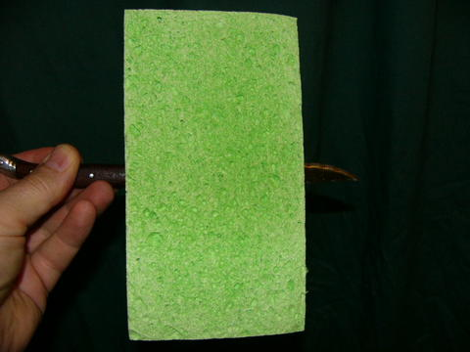
Cut hole in center
Insert knife through width in centers of all sponges

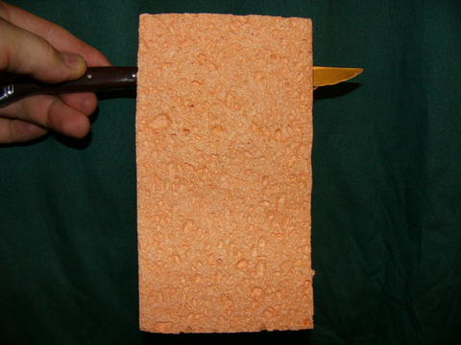
Holes near the ends
Each sponge gets 3 holes. One in the center, and other two as shown near the ends. They go across the width of the sponge

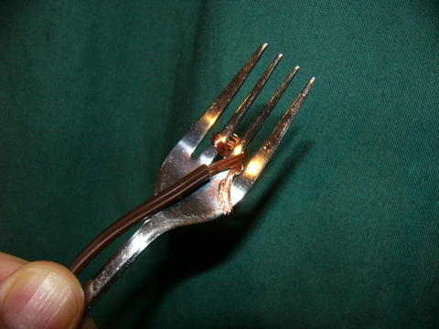
Stainless steel or silver fork
Cut the insulation off the wire end, and wrap it into the fork end as shown. This will carry electricity. If you don't have forks, use other long thin metal object

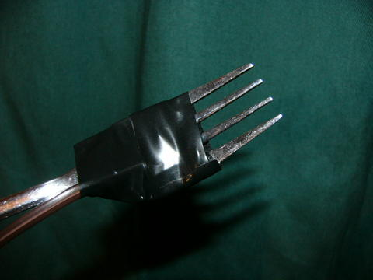
Tape over the wire
Leave about half of the fork prongs exposed and tape over the rest. The exposed parts will carry electricity into the sponge.

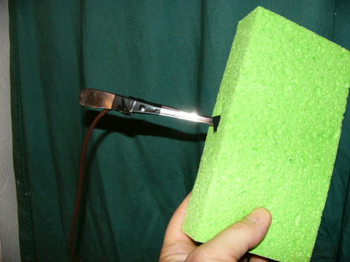
Stick fork into 1st sponge
Note the tape on the fork near the handle. Leave some fork not taped in the middle and the end of handle.

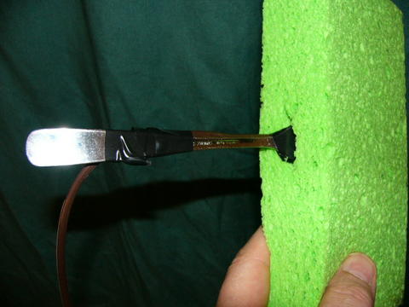
Close-up of fork and sponge
This shows the taping and inserting of fork and sponge

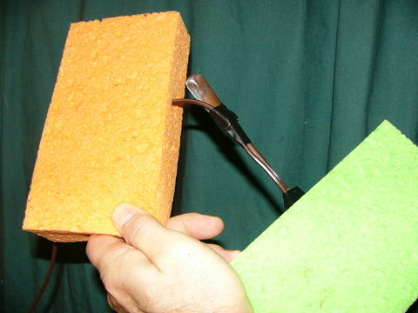
Put 2nd sponge onto wire
String the wire through the center of the 2nd sponge

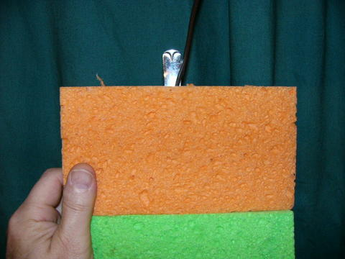
Slide 2nd sponge down
The 2nd sponge goes onto the wire and fits down against the side of the first sponge

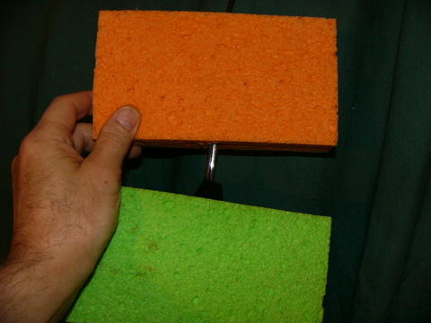
Add 3rd sponge
The 3rd sponge goes onto the wire and the handle of the fork.

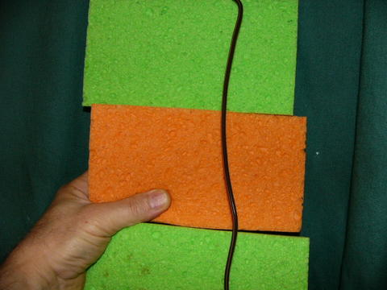
Fork inside all 3 sponges
The wire and fork go inside all 3 sponges. Some of the bare metal of the fork touches each sponge.

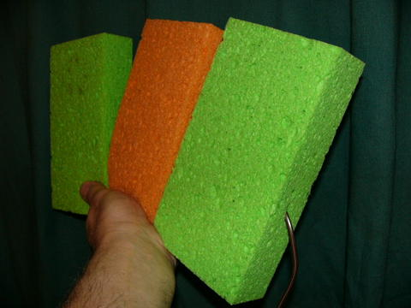
Closeup shows wire
The wire comes out of one end.

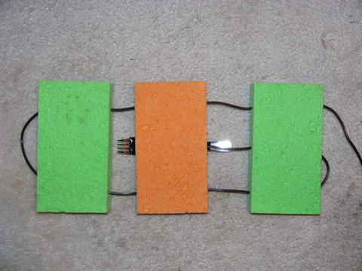
String wire through end holes
Wire goes around in a circle through the ends of each sponge, holding them all together.

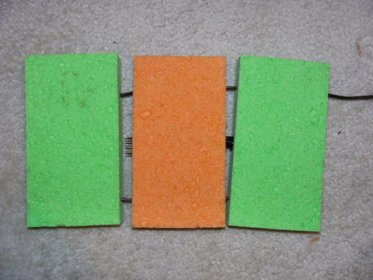
Pull sponges together
Tighten the wire so all sponges come together with the fork inside each sponge

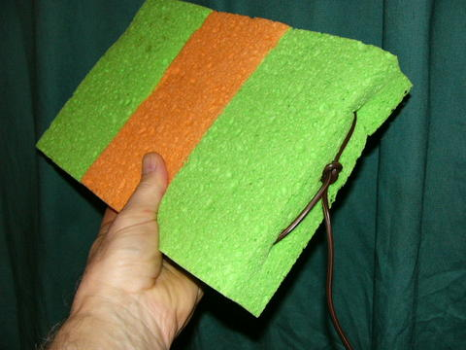
Tie a knot
The wire is tied with a single knot to make a complete gutzilla pad

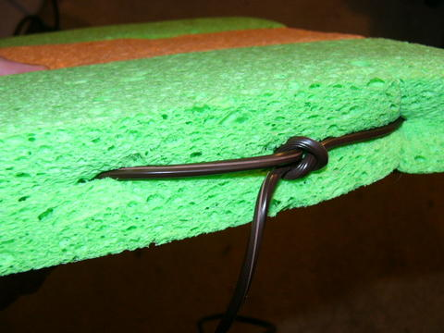
Closeup of knot
The wire is tied to itself in a single knot to hold all sponges and wires tight.

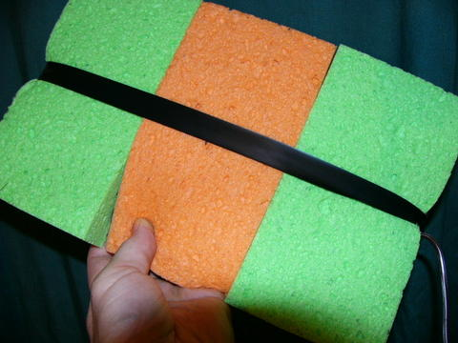
Add tape
Tape around the three sponges to keep them from coming apart

DONE!!
The following pictures and descriptive text were taken verbatim from the microelectricitygermkiller Yahoo Group at:

http://health.groups.yahoo.com/group/microelectricitygermkiller/

The Paddles

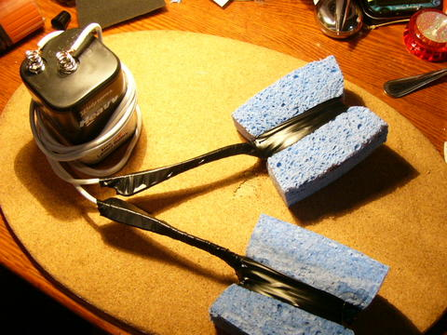
Parts needed: 6Volt battery, wire, 2 forks, big cellulose1.5 inch thick sponge, electrical or other waterproof tape
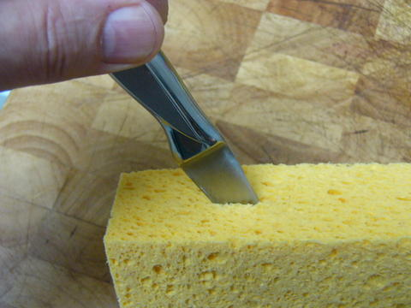
Make two cuts about 2 inches deep into side of sponge near the middle as shown. Forks will be inserted into them
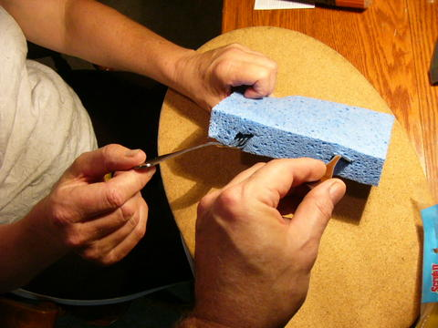
Shows where two forks go into sponge. Forks can be stainless or silver with plastic or metal handles.
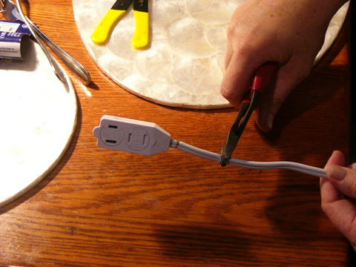
Cut off the ends of a 6 foot extension cord. (unplug it first!)
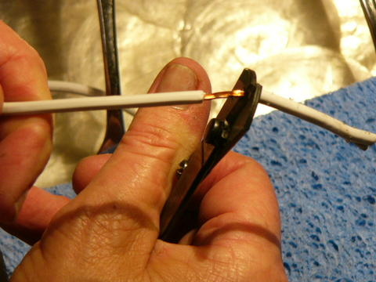
Split the wire and strip off insulation about 2 inches on all 4 ends
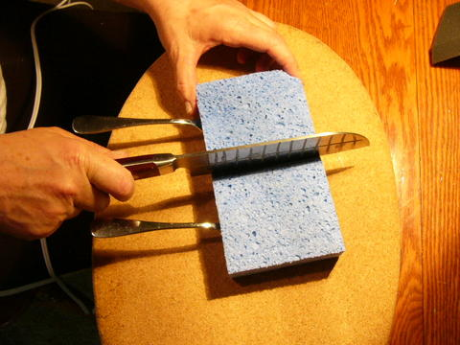
Cut the sponge in half
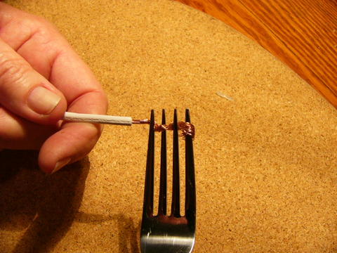
Twist the wire and wrap it between the prongs of the fork
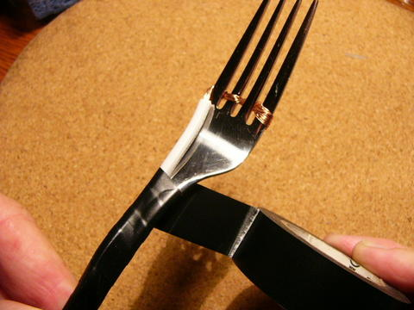
Slide the wire all the way down. Wrap fork with tape starting from the bottom of the handle going up toward the prongs.
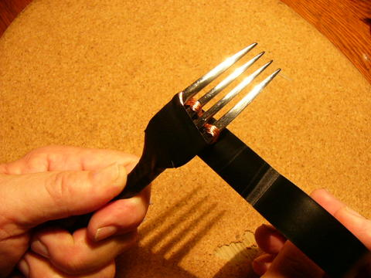
Go around the wire with the tape and keep going
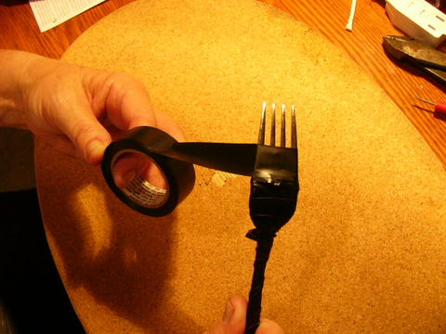
Here is where you can adjust the power by how much metal shows. More metal means more power. Less metal means less power. Suit yourself, you can always change it later by unwrapping or adding tape.
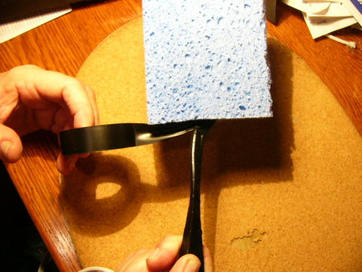
Stick the fork in all the way.
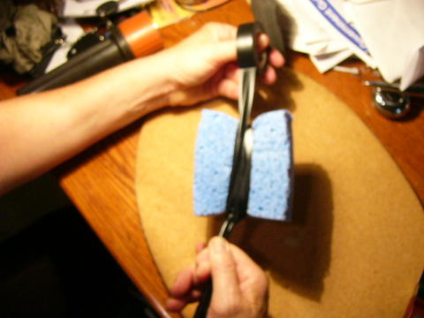
Wrap tape up over the sponges to hold them in place on the forks
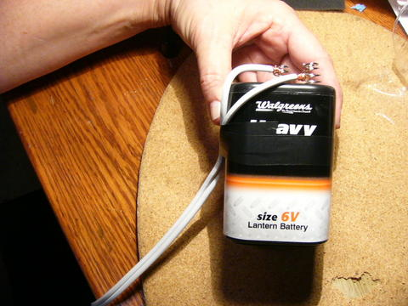
Attach free ends of wire to battery terminals by twisting wires tightly. It does not matter which goes to positive or negative. Wrap tape around wires and battery to hold wires tightly to battery
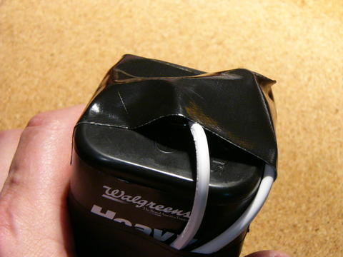
Vital. Tape over the top to ensure wires stay on and they don't touch anything. Fires or dead batteries can result if you don't do this.
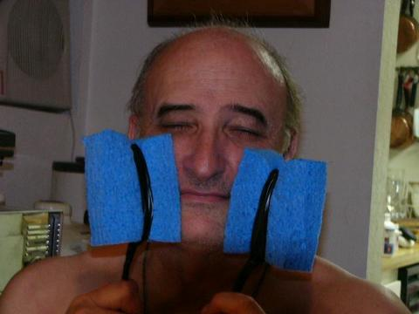
Inventor shown holding pads against face. Pads are wrung out so nearly dry. Do not use them soaking wet, it is too strong. Move them around, reverse pads from left to right every 5 minutes or so. Slight flash is optic nerve sensitivity, shows it is connected.
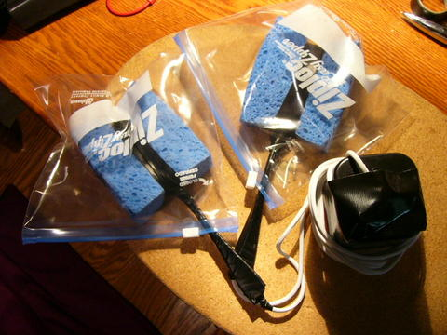
When storing, always put the pads into plastic bags to keep them from touching.

DONE!!!

