**[The Power Of Quran Healing](http://kaheel7.com/eng/index.php/secrets-of-quran-a-sunnah/69-the-power-of-quran-healing) Cancer Cells HZ**

[**http://kaheel7.com/eng/index.php/secrets-of-quran-a-sunnah/69-the-power-of-quran-healing**](http://kaheel7.com/eng/index.php/secrets-of-quran-a-sunnah/69-the-power-of-quran-healing)

|  |  |
| --- | --- |
|  | There are many cases cured every day by reciting the Koran; we cannot deny that because recovery does happen; it happened to me when I was reciting specific verses for a specific illness and the illness was cured! |

Koran Healing is a critical issue which wasn’t given enough study or research, so I thought about starting this journey and asked Allah to guide me, give me the useful knowledge, show me the right and help me do it, and show me the wrong and help me avoid it. One of the most important fruits of this research, which continued for years, was that I came out with an important result: Allah had put in every verse of the Koran a healing power for a certain disease if this verse was recited for a specific number of times.

**In the beginning**

When we contemplate on the universe around us, we notice that every single atom is vibrating in a specific frequency, whether this atom is part of metal, water, cell, or anything else. So every thing in this universe is vibrating, this is a given scientific fact.

The basic structure of the universe is the atom, and the basic structure of our bodies is the cell; each cell is made of billions of atoms and each atom is made of a positive nucleus and negative electrons rotating around it; because of this rotation, an electromagnetic field is generated similar to fields generated by an engine.

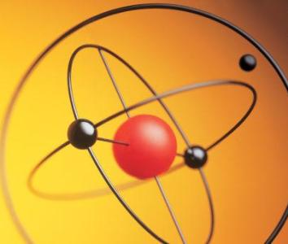

*The atom is the basic structure in the universe and in our bodies; it is constantly vibrating which means that every thing is vibrating according to a precise system. Cells vibrate in a precise system, and any vibration around us affects our cells.*

The secret that makes our brain think is an accurate program inside the brain cells; this program is inside every cell doing its task precisely; the smallest defect in its job would cause imbalance and disorder of some of the body parts; the best cure for this imbalance is to restore balance to the body. Scientists discovered that body cells are affected by various vibrations such as light waves, radio waves, sound waves etc. But what is sound?

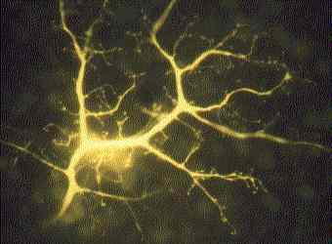

*Each cell in our body vibrates in a precise system, and the smallest change in this vibration would mean an illness of some part of the body. That's why these damaged cells should be vibrated to restore balance to them.*

We know that the sound is made of waves or vibrations moving in the air in about 340m/sec. Each sound has its own frequency, and human can hear from 20 frequencies per second to 20000 frequencies per second (1). These waves spread in the air and then get received by the ear, then turn into electrical signals and move along the acoustic nerve towards the acoustic bark in the brain; the cells correspond to the waves and move into the various parts of the brain especially the frontal part; all these parts work together corresponding to the signals and translating them to a language the human understands. Thus, the brain analyses the signals and gives its orders to the various body parts to correspond to these signals.

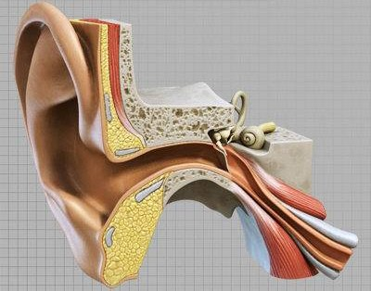

*The sound is made of mechanic vibrations that reach the ear then the brain cells which correspond to these vibrations and change their own vibration; that's why the sound is considered an effective healing power depending on the nature of the sound and its frequencies. We find the healing power in the Koran because it is the book of Allah.*

From here came sound therapy; the sound is a vibration, and body cells are vibrating, then the sound influences these cells. This is what researchers discovered recently; in Washington University late in the twentieth century, scientists found that the job of a brain cell is not just to transfer information, each cell is a small computer working on collecting information, processing it, and giving orders continuously round the clock. Ellen Covey, a researcher in Washington University, says that it is the first time that we realize that the brain does not work as a big computer, but it contains a huge number of computers working in a cooperative way, there is a small computer in each cell, and these computers are affected by the vibrations around them, especially the sound (2).

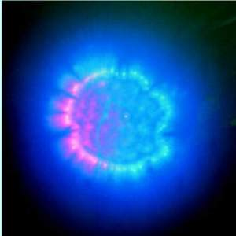

*Experiments show that inside each cell in the brain there is a tiny computer which Allah deposited an accurate program that directs the cell and controls its work. They also show that the sound affects the cell; this is a picture of a cell getting affected by a sound and an electromagnetic field is being formed around it.*

Thus, we can say that the cells of each body part vibrate in a specific frequency, and form a complicated and coordinated system that is affected by any sound around it. So, any disease affecting any part of the body will cause a change in the vibration of this part's cells and thus causing it to deviate from the general body system affecting the whole body. This is why, when the body is exposed to a specific sound, this sound influences the vibration system of body and especially the irregular part; this part would respond to specific sounds to restore its original vibration system or, in other words, to restore its healthy condition. Scientists discovered these results recently. What is the story of this science (the sound therapy)?

**Sound therapy story**

Alfred Tomatis, a French doctor, made experiments for fifty years about the human senses and came out with the result that the hearing sense is the most important sense!! He found that the ear controls the whole body, regulates its vital operations and the balance and coordination of its movements; he also found that the ear controls the nervous system!

During his experiments, he found that the hearing nerves connect with all body muscles and this is the reason why the balance and flexibility of the body and the sight sense get affected by sounds. The inner ear is connected with all the body parts such as the heart, lungs, liver, stomach, and the intestines; this explains why sound frequencies affect the whole body (3).

In 1960, the Swiss scientist Hans Jenny found that the sound affects the various materials and reform their particulars, and that each cell of the body has its own sound and gets affected by the sounds and rearranges the material inside it (4). In 1974, the researchers Fabien Maman and Sternheimer made an astonishing discovery; they found that each part of the body has its own vibration system, subject to physics laws. A few years later, Fabien and Grimal, another researcher, discovered that sound affects cells especially cancer cells, and that certain sounds had stronger effect; the strange thing the two researchers found was that the sound that had the strongest effect on body cells is the sound of the human himself!!

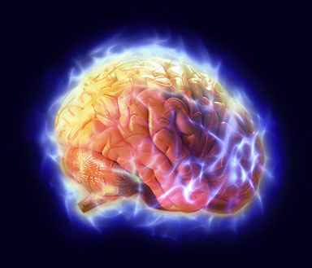

*The sound moves from the ear to the brain and affects the brain cells; scientists recently found that the sound has a strange healing power and an amazing effect of the brain cells which work on restoring the balance to the whole body! Reciting Koran has an astonishing effect on these cells and is capable of restoring their balance; the brain is the organ that controls the body and from it the orders comes to the rest of the body organs especially the immune system.*

Fabian, a scientist and musician, put blood cells from a healthy body and exposed them to various sounds; he found that each note of the musical scale affects the electromagnetic field of the cell; when photographing this cell with Kirlian camera, he found out that the shape and value of the electromagnetic field of the cell change according to the sound frequencies and the sound type of the reader. Then he made another experiment taking a blood drop from one of the patients, and then he monitored the drop with Kirlian camera and asked the patient to make various notes. He found, after processing the pictures, that on a specific note the blood drop changes its electromagnetic field and fully vibrates responding to its owner. He thus concluded that there are specific notes that affect the body cells and make them more vital and active, even regenerates them. He came out with an important result: The human sound has a powerful and unique influence over body cells; this influence is not found in any other instrument. This researcher said literally:

"The human sound has a special spiritual ring making it the most powerful healing device (5). Fabien found that some sounds easily explode the cancerous cell, and at the same time activate the healthy cell. The sound affects human blood cells which transfer the frequencies of this sound to the whole body through the blood circulation".

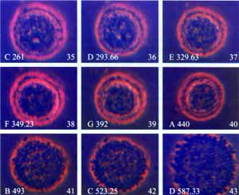

*A cancerous cell exploded by using sound frequencies only!! That's why reciting the Koran has a great impact on treating the most danger cancers and incurable diseases!*

But is this influence limited only to cells? It became clear that sound affects everything around us. This is what Masaru Emoto, a Japanese scientist, proved in his experiments on water; he found that the electromagnetic field of water molecules is highly affected by the sound, and that there are specific tones that affect these molecules and make them more regular. If we remember that the human body is 70% water, then the sound the human hears affects the regularity of water molecules in the cells and the way these molecules vibrate, thus affects his healing (6). Different researchers confirm that the human sound could heal many diseases including cancer (7). Sound therapists also confirm that there are certain sounds that are more effective and have a healing power especially in increasing the immune system efficiency (8).



*Water molecules shape changes when exposed to sound; thus, sound greatly affects the water we drink. If you recite the Koran on water, its characteristics would change and it would carry the Koran effect to every cell in the body causing them to heal !In the picture, we see a frozen water molecule; the electromagnetic field around this molecule changes continuously because of the sound effect.*

**How Koran heals?**

Now, let's ask the important question: what happen inside body cells and how does sound cure? How does this sound affect the damaged cells and restore their balance? In other words, what is the mechanism of healing?

Doctors are constantly looking for means to destroy some virus; if we think about the mechanism of this virus, what moves it and makes it recognize its way to the cell? Who gave the virus the information stored within which enables it to attack the cells and multiply inside? What moves the cells against this virus to destroy it while stand helpless in front of another virus?

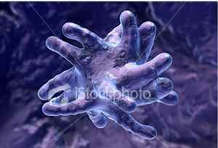

*Viruses and germs also vibrate and are highly affected by sound vibrations especially the Koran sound; it stops them and at the same time increases the activity of the healthy cells and revives the disrupted program inside so to become ready to fight viruses and germs.*

The Koran recitation is made of a group of frequencies that reach the ear then move to the brain cells and affect them through the electronic fields these frequencies generate in these cells; the cells would respond to these fields and modify their vibrations, this change in the vibration is what we fell and understand after experience and repetition.

It is the natural system that Allah gave to the brain cells, it is the natural balance system; this is what Allah told us in the holy Koran: (Allah's handiwork according to the pattern on which he has made mankind: No change let there be in the work (wrought) by Allah: that is the straight religion, but most of men know not) (Al-Rum, 30).

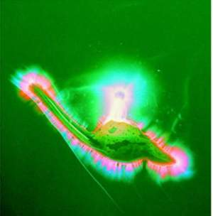

*A real picture of a blood cell that was exposed to the sound and started changing the electromagnetic field around it; the sound of the Koran changes the information this cell carries and makes it more capable of fighting viruses and the defect Resulting from malignant diseases.*

**What are the healing verses?**

Dear reader, each verse of the Koran has an amazing healing power for a specific disease; what is confirmed is that the Prophet, Allah's peace and blessing be upon him, focused on specific chapters and verses, such as reading Al-Fatiha seven times, Al-Kursi verse (verse number 255 in Al-Bakara chapter), the last two verses of Al-Bakara Chapter, and the last three chapters of the Koran.

But the whole Koran heals; you can, dear brother, read the verses that you hope to cure your illness. For example, if you feel upset, focus your reading on Al-Sharh chapter (Have We not opened your breast for you); if you have a sever headache, read: (Had We sent down this Koran on a mountain, you would surely have seen it humbling itself and rending asunder by the fear of Allah. Such are the parables which We put forward to mankind that they may reflect) (Al-Hashr, 21); if you are suffering from pimples, warts, or skin problems then read: (then it is struck with a fiery whirlwind, so that it is burnt) (Al-Baqarah, 266).

If you are afraid, keep repeating Korish chapter, especially the verse: (and has made them safe from fear) (Korish, 4). A strong cure of depression is the repetition of these verses from the Holy Koran: (O mankind! There has come to you a good advice from your Lord (the Koran) and a healing for the diseases in your breasts, a guidance and a mercy for the believers* Say: "In the Bounty of Allah, and in His Mercy (i.e. Islam and the Koran); therein let them rejoice." That is better than what (the wealth) they amass) (Yunus, 57-58).

The greatest prophet peace be upon him used to say hundreds of supplications every day, do you think he was doing it in vain? He was asking Allah to protect him from evil, including diseases. You can say the supplication that protect you from diseases every day: (I seek refuge in Allah's perfect words that are obeyed by the faithful and the immoral from all that He created, made in earth and originated from it, from all that come from heaven and ascend into it, from the seductions of the day and the night, and from the night and day visitors except those who bring good, O you most Gracious). Don’t you agree with me that this great prophetic supplication is the best protector from any disease?

Thus, dear brothers and sisters, you can find in the Koran and Sunnah a cure for any disease whether psychological or physical; it is preferred to read the verses in a loud voice so to make your body cells get affected by the sound of the Koran, and to focus on the sick part and imagine that Allah has cured it; repeat these verses and start each time with Al-Fatiha and finish with Al-Falaq and Al-Nas. You can also ask for the verses that are relevant for your disease.

O Allah, make the Koran our cure for every disease.   
-------------------

By: Abduldaem Al-Kaheel

[www.kaheel7.com/eng](http://www.kaheel7.com/eng)

**Sources:**

(1) the sound frequencies are measured by hertz, which is a measurement meaning one vibration each second; these sound frequencies are different from one human to another and according to what the human is saying.

(2) Joel Schwarz, How little gray cells process sound: they're really a series of computers, University of Washington, Nov. 21, 1997.

(3) Tomatis Alfred, The Conscious Ear, Station Hill Press, New York, 1991.

(4)Jenny Hans, Cymatics, Basilius Presse AG, Basel, 1974.

(5) Maman Fabien, The Role of Music in the Twenty-First Century, Tama-Do Press, California, 1997.

(6) Emoto Masaru. The Message from Water,HADO Kyoikusha. Tokyo, 1999.

(7) Keys Laurel Elizabeth, Toning the Creative Power of the Voice, DeVorss and Co. California, 1973.

(8)Simon Heather, The Healing Power of Sound, www.positivehealth.com.

(9) Kara Gavin, University of Michigan researchers publish new findings on the brain's response to costly mistakes, University of Michigan, April 12, 2006.

(10) Brain Scans as Lie Detectors: Ready for Court Use?, Malcolm Ritter, www.livescience.com, 29 January 2006.

(11) Carl T. Hall, Chronicle Science Writer, Fib detector Study shows brain scan detects patterns of neural activity when someone lies, www.sfgate.com, November 26, 2001.